**Quantifying the Financial Impact of Biodiversity Net Gain (BNG) Offsets in Surrey with a 20% Uplift**

Nishtha Singh

**Executive Summary**

The project titled **"Quantifying the Financial Impact of Biodiversity Net Gain (BNG) Offsets in Surrey with a 20% Uplift"** aims to assess the feasibility and implications of achieving a 20% Biodiversity Net Gain (BNG) in Surrey by 2030, with a primary focus on species protection. The project was developed in response to the UK’s biodiversity crisis, which has been exacerbated by habitat loss, pollution, and climate change. As part of the Environment Act 2021, the UK government introduced the BNG initiative, which mandates that new developments must contribute positively to biodiversity. This project seeks to integrate financial, ecological, and spatial analyses to provide a comprehensive framework for guiding conservation efforts in Surrey, ensuring that biodiversity gains are maximized within the constraints of available resources.

The methodology employed in this project involved a mixed-methods approach, combining quantitative data analysis with qualitative insights. Data was sourced from DEFRA’s MAGIC Map, HM Land Registry, and Surrey Wildlife Trust, offering detailed information for financial modelling and ecological assessments. These data sources provided critical insights into land use, habitat types, and the costs associated with habitat creation, restoration, and maintenance. Stakeholder consultations offered qualitative insights, ensuring that the project’s findings aligned with practical conservation needs and regional priorities.

Key analytical tools included Geographic Information Systems (GIS) for spatial analysis, regression models for financial forecasting, and scenario planning to explore different conservation strategies. These tools allowed for a thorough examination of the ecological and financial feasibility of achieving the 20% BNG target. Additionally, a data visualization framework using Power BI was developed to present the findings clearly, facilitating effective decision-making among stakeholders.

The analysis yielded several critical findings. First, it was determined that targeting cost-effective habitats like Heathland, Calcareous Grasslands, Reedbeds, and Urban Green Spaces would yield the highest ecological returns on investment. These habitats offer a balance of high ecological value and manageable restoration costs, making them strategic priorities. Second, the project challenged traditional conservation priorities by demonstrating that significant biodiversity improvements can be achieved without focusing solely on the most expensive habitats. This insight is particularly valuable in resource-limited scenarios, where efficient resource allocation is crucial. Third, the analysis highlighted the importance of habitat connectivity in maintaining biodiversity. Larger, more connected habitats were found to support higher biodiversity levels and greater species survival rates, underscoring the need for conservation strategies that enhance connectivity in fragmented landscapes.

The methodologies employed in this project, including financial modelling, ecological evaluation, and spatial analysis, proved effective in achieving the project’s objectives. The integration of these approaches provided a nuanced understanding of the trade-offs involved in conservation efforts, ensuring that financial investments were directed toward areas with the most significant ecological impact. The use of GIS and predictive modelling techniques further strengthened the project’s effectiveness by enabling precise analysis of habitat connectivity and species distribution.

Based on these findings, several key recommendations were developed. First, a phased restoration approach should be implemented, beginning with the most degraded and fragmented habitats, such as Wet Woodland and Hedgerows. These areas offer the potential for immediate biodiversity benefits with targeted restoration actions. Second, a comprehensive biodiversity monitoring framework should be established to track biodiversity changes over time, utilizing advanced GIS tools and remote sensing technology. Third, conservation efforts should prioritize habitats that offer high ecological returns on investment, such as Heathland and Urban Green Spaces, to maximize the effectiveness of resource allocation. Fourth, efforts should be made to enhance habitat connectivity by investing in projects that improve links between fragmented habitats, facilitating species movement and genetic exchange. Finally, targeted species recovery initiatives should be implemented, focusing on at-risk species that play a crucial role in maintaining ecosystem health.

The implications of this project are significant for biodiversity conservation in Surrey and beyond. By providing a clear and actionable roadmap for achieving the 20% BNG target, this project supports Surrey’s long-term conservation goals and offers a model that can be adapted to other regions with similar challenges. The integration of financial, ecological, and spatial analyses represents a significant advancement in conservation planning, ensuring that biodiversity gains are maximized within available resources. Furthermore, the project challenges conventional conservation priorities, demonstrating that cost-effective habitats can yield significant biodiversity improvements, even in resource-constrained environments.

While the project has laid a strong foundation for biodiversity conservation in Surrey, it also highlights areas for future research. Long-term monitoring of the ecological impacts of the recommended strategies will be essential to ensure their sustainability. Additionally, further exploration of advanced predictive modelling techniques could refine cost projections and impact assessments, enhancing the adaptability and effectiveness of conservation planning. Lastly, considering the integration of higher-cost habitats into future conservation plans, especially with secured funding, could provide a more comprehensive approach to achieving BNG targets.

In conclusion, this consulting project successfully developed a robust framework for achieving a 20% BNG uplift in Surrey by 2030, focusing on species protection. The findings and recommendations presented offer a replicable model for other regions facing similar challenges, contributing to the broader effort to protect and enhance global biodiversity. This work underscores the importance of a strategic, data-driven approach to conservation that balances ecological soundness with economic viability.

**Table of Contents**

1 Introduction 1

1.1 Background 2

1.2 Project Aim and Objectives 3

1.3 Research Approach 4

1.4 Report Outline 5

2 Trends and Theoretical Perspectives 7

2.1 Current Trends 7

2.2 Theoretical Frameworks 8

2.3 Critical Evaluation 9

2.4 Knowledge Gap and Insights Sought 10

3 Analytical Framework and Method 12

3.1 Research Methodology 12

3.2 Research Design 14

3.3 Ethical Considerations 1

4 The Data 2

4.1 Data Description 2

4.2 Source Justification 4

4.3 Data Preparation 4

4.4 Data Assumptions and Limitations 5

5 The Analysis 7

5.1 Analysis Progression 7

5.2 Descriptive Analytics 8

5.3 Diagnostic Analytics 9

5.4 Predictive Analytics 11

5.5 Prescriptive Analytics 16

5.6 Analytical Adjustments and Assumptions 19

6 Findings and Recommendations 21

6.1 Project Contribution 21

6.2 Recommendations 21

6.3 Project Limitations 22

6.4 Future Opportunities for Research 23

7 Conclusion 25

8 Bibliography 28

Appendices 31

Appendix A: Ethical Approval Form 32

Appendix B: Project Development Diary 33

9 My MN5821 Development Diary 34

Appendix C: Declaration of AI Tool Usage 38

# Introduction

The accelerating decline in biodiversity poses a significant threat to global ecosystems, with species loss being a critical concern. Protecting and enhancing biodiversity has become an urgent priority, particularly in regions like Surrey, where unique species and habitats are under threat from urbanization and environmental degradation. This project is cantered on assessing the feasibility and implications of achieving a 20% Biodiversity Net Gain (BNG) in Surrey by 2030, with a strong emphasis on species protection.

The project integrates financial, ecological, and spatial analyses to identify key habitats for restoration and to develop strategies that maximize biodiversity gains while ensuring the survival of critical species. Utilizing a mixed-methods approach, the analysis combines quantitative data with insights from stakeholder consultations to create a robust framework for biodiversity conservation that is both scientifically sound and practically applicable.

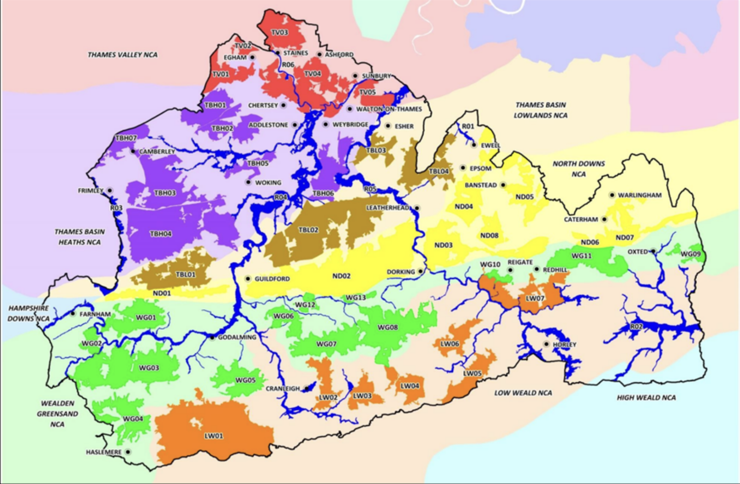

**Figure 1:Biodiversity Opportunity Areas, Surrey**

## Background

Surrey’s rich biodiversity is increasingly threatened by habitat loss, pollution, and climate change, putting many native species at risk of extinction. The UK government’s Biodiversity Net Gain (BNG) initiative, part of the Environment Act 2021, seeks to reverse these trends by mandating those new developments result in a net positive impact on biodiversity. In Surrey, where species protection is paramount, the implementation of BNG is crucial for safeguarding the region’s ecological integrity.

The Surrey Wildlife Trust’s 30x30 initiative, which aims to protect 30% of the county’s land by 2030, further emphasizes the need for targeted conservation efforts. This project addresses the gap in current species protection strategies by focusing on the financial and ecological viability of achieving a 20% BNG uplift, particularly in habitats critical for the survival of endangered and keystone species.

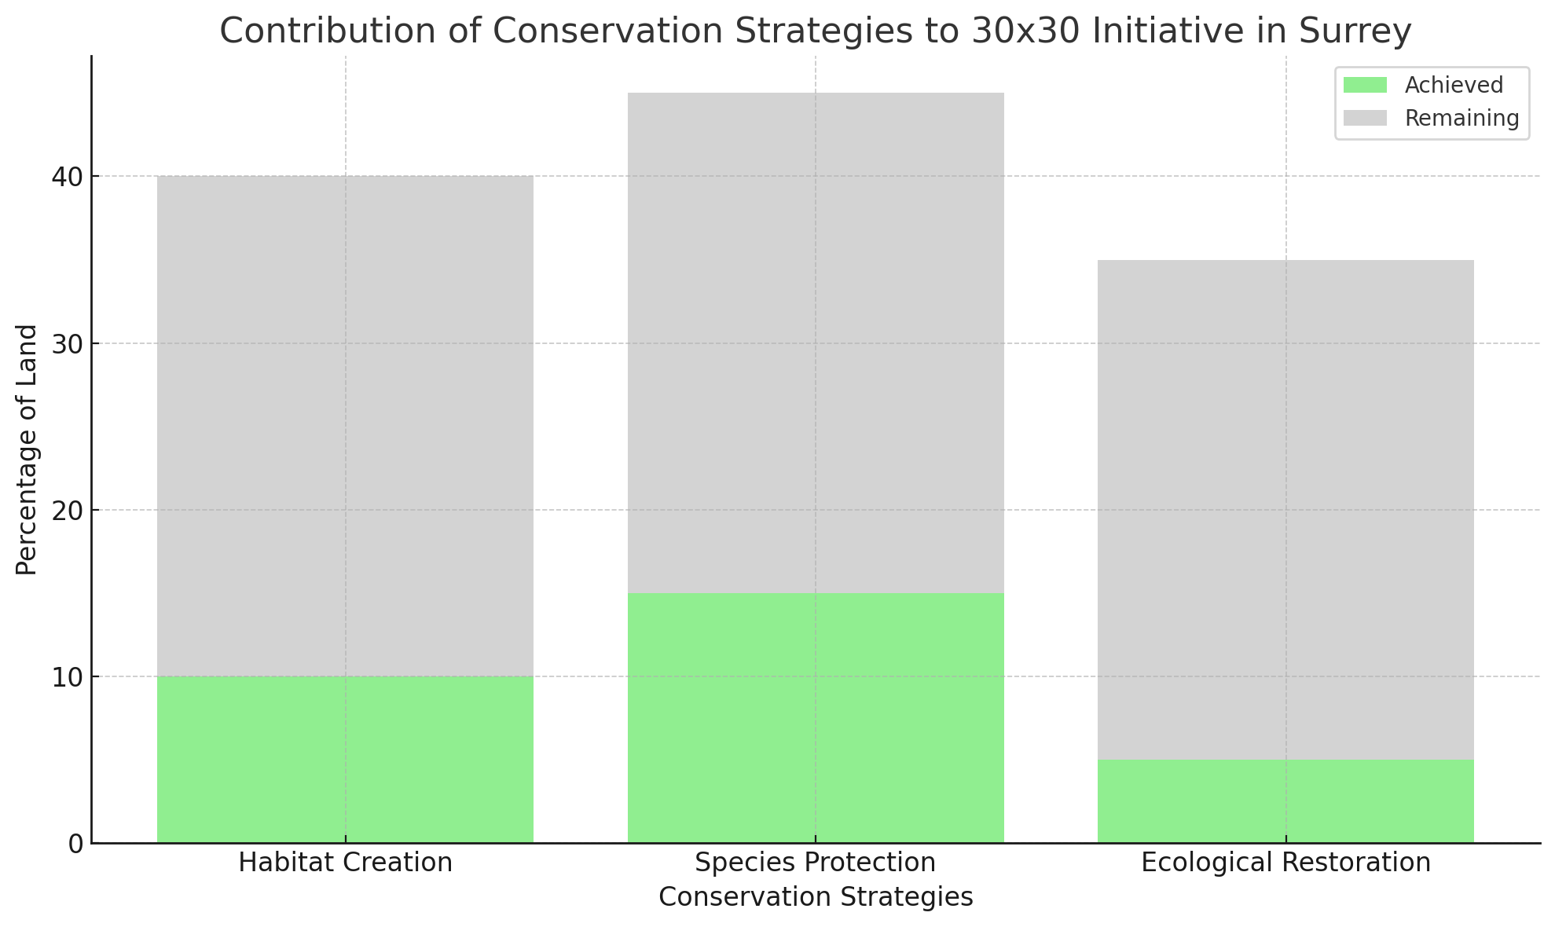

**Figure 2: Contribution of Conservation Strategies**

## Project Aim and Objectives

The purpose of this project is to quantify both the financial and ecological impacts of achieving a 20% Biodiversity Net Gain (BNG) uplift in Surrey. This analysis involves in assessing the associated costs of creation, habitat restoration and long-term maintenance. It will also explore the potential ecological improvements that could result from enhanced biodiversity.

The specific goals of the project are to:

1. **Examine the current state of biodiversity and land use in Surrey**, with a focus on 30x30. Identifying areas that could benefit from habitat enhancement.
2. **Calculate the financial requirements necessary to achieve the proposed BNG uplift**. Determining costs related to land acquisition, habitat creation, and ongoing maintenance.
3. **Facilitate stakeholder decision-making** by crafting strategic recommendations interactive dashboards to present the findings in a clear and impactful way, that align with Surrey's conservation goals.
4. **Develop strategic recommendations** to guide the successful implementation of the BNG uplift, ensuring that it aligns with Surrey’s long-term conservation strategies.

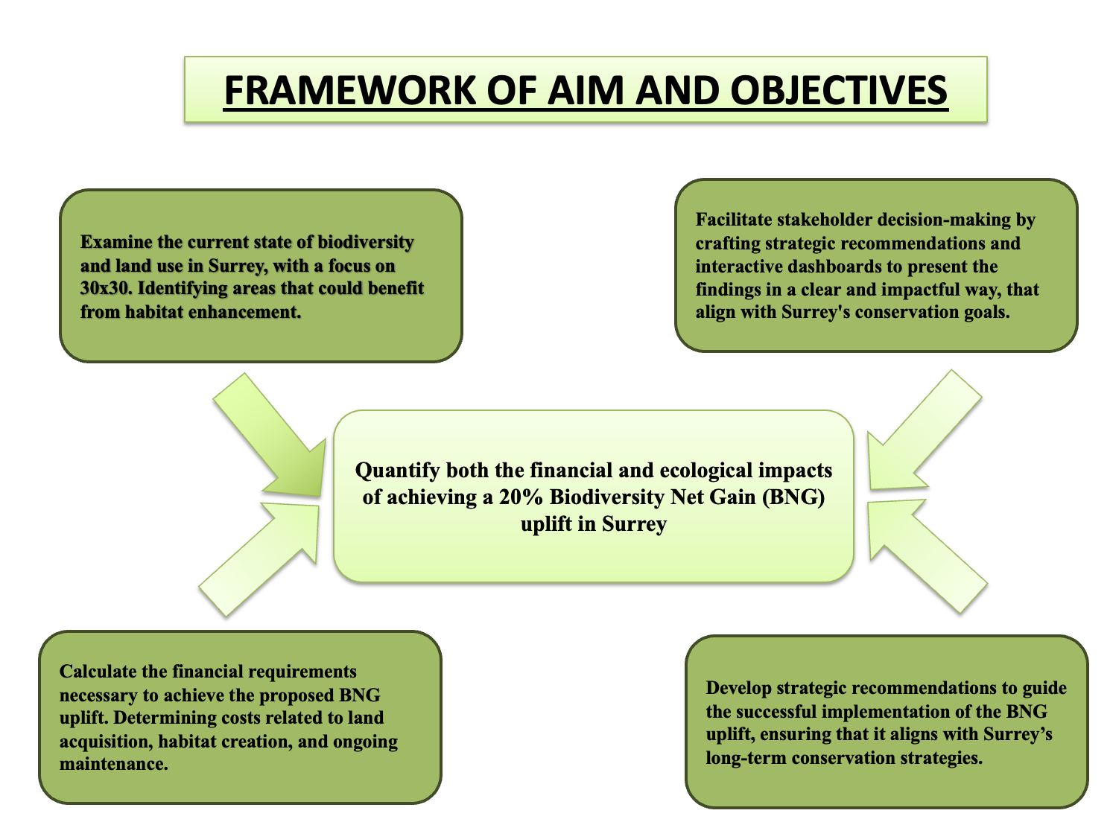

**Figure 3: Aims and Objectives**

## Research Approach

The research employs a mixed-methods approach, integrating both quantitative and qualitative analyses to achieve the project’s objectives. Quantitative data were sourced from DEFRA’s MAGIC Map, HM Land Registry, and the UK Land Registry, which provided crucial information for financial modelling and ecological assessments. This data includes detailed cost estimates for land purchase, habitat creation, and maintenance across various habitat types in Surrey. Qualitative insights were gathered through stakeholder consultations and interviews, offering a deeper understanding of the challenges and opportunities related to implementing Biodiversity Net Gain (BNG) targets.

The data analysis approach involved the use of scenario analysis and comprehensive dashboard development to visualize outcomes. The scenario analysis explored potential ecological impacts under different BNG uplift scenarios, allowing for a better understanding of how these strategies might affect biodiversity in Surrey. Additionally, the analysis employed various quantitative techniques, including regression models and sensitivity analysis, to ensure the robustness of the findings.

Key tools and frameworks used in the analysis include Geographic Information Systems (GIS) for spatial analysis and Python libraries for data processing and predictive modelling. These tools were essential for integrating the financial, ecological, and spatial data, providing a holistic view of the potential outcomes of the BNG strategies.

The scope of the project was subject to several limitations. Temporal constraints, such as fixed timelines for achieving the BNG targets, imposed boundaries on the analysis. The assumptions made in the analysis, such as the consistent application of an inflation rate, also introduced potential biases. Furthermore, methodological constraints, including the reliance on specific analytical tools and models, limited the ability to fully capture the complexities of ecological systems. Despite these limitations, the chosen approach effectively supports the project’s aim of achieving a 20% BNG in Surrey by 2030.

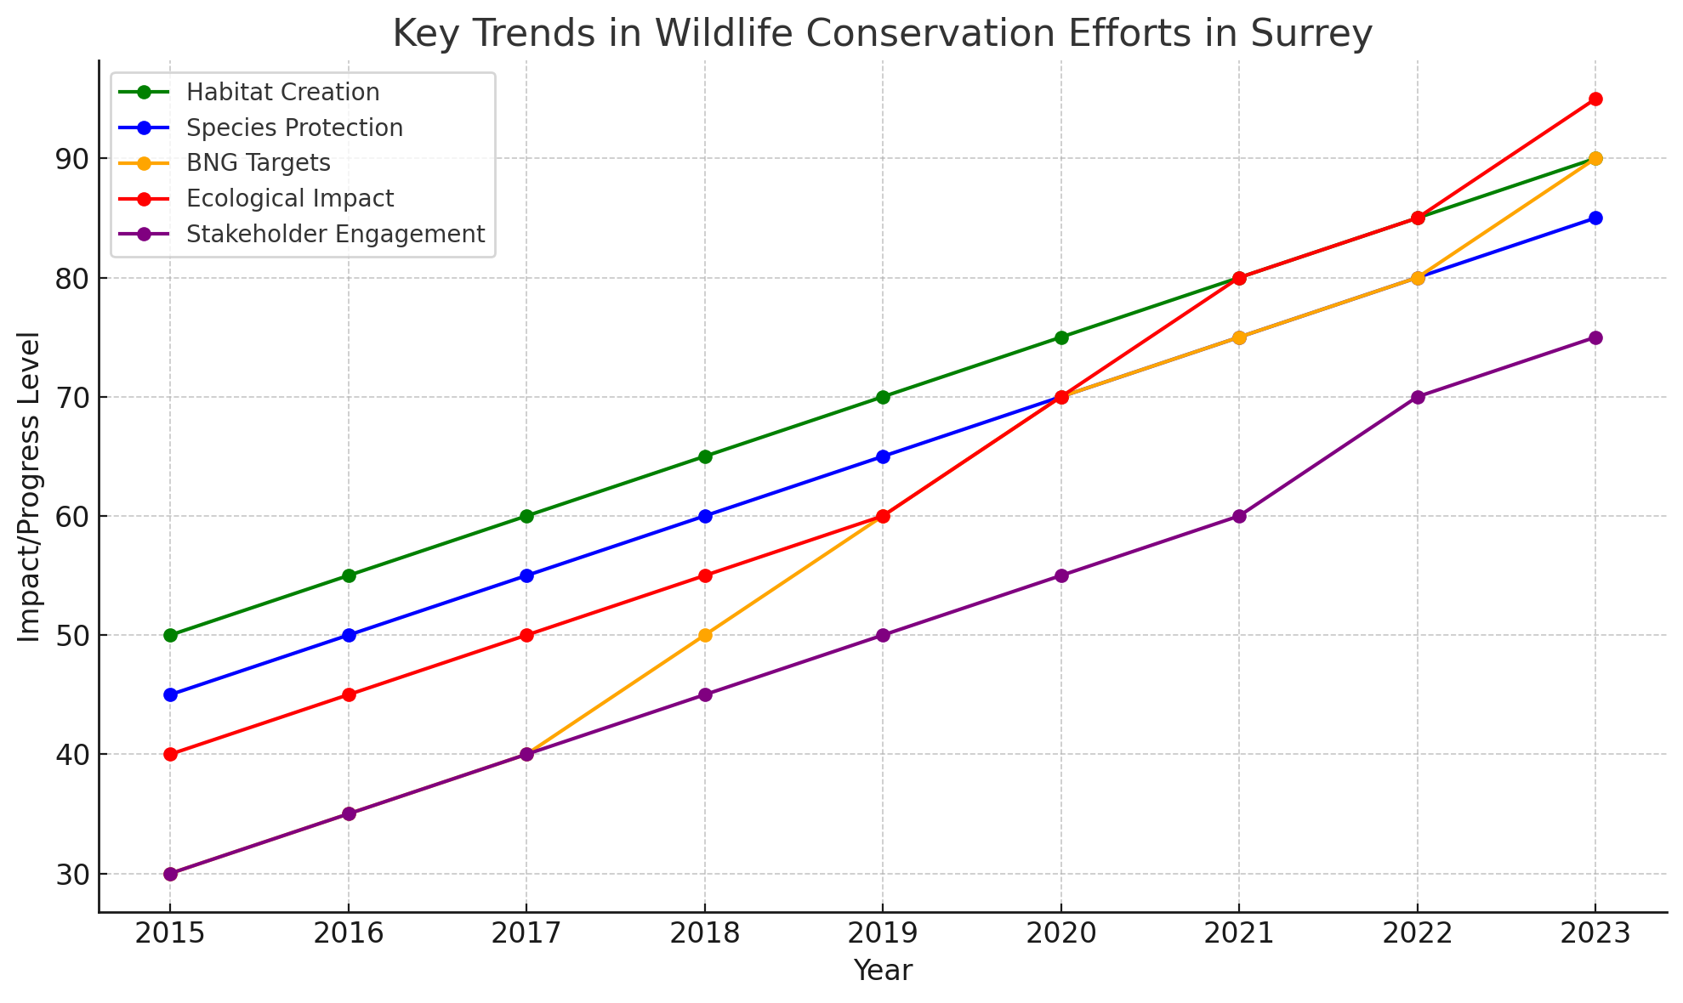

**Figure 4: Wildlife Conservation Efforts**

## Report Outline

The report is organized to provide a clear and logical progression through the analysis:

Section 2: Trends and Theoretical Perspectives explores current trends in biodiversity conservation, focusing on financial modelling, ecological evaluation, and spatial analysis, and establishes the theoretical foundation for the project. Section 3: Analytical Framework and Methodology details the research methods, justifying the chosen quantitative and spatial techniques while addressing ethical considerations. Section 4: Data Overview examines data sources, preparation, and assumptions, ensuring their relevance to the research objectives. Section 5: Analysis presents findings from descriptive, diagnostic, predictive, and prescriptive analyses, highlighting contributions to achieving Surrey’s 20% Biodiversity Net Gain (BNG) targets. Section 6: Findings and Recommendations summarizes insights, offers actionable recommendations tailored to Surrey Wildlife Trust, and identifies project limitations and future research opportunities. Section 7: Conclusion reflects on the broader implications of the findings and suggests directions for continued biodiversity conservation in Surrey.

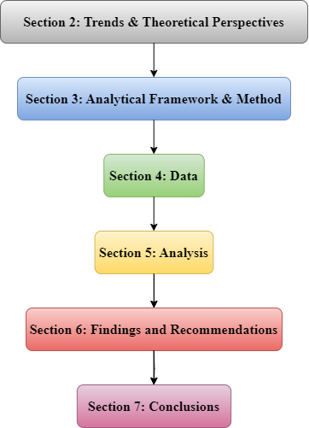

**Figure 5: Report Outline**

# Trends and Theoretical Perspectives

The evolving landscape of biodiversity conservation requires examining key trends, theoretical frameworks, and critical evaluations. This analysis focuses on integrating financial modelling, ecological evaluation, and spatial analysis, particularly in achieving the 20% Biodiversity Net Gain (BNG) uplift in Surrey, while addressing existing knowledge gaps in conservation planning.

## Current Trends

Biodiversity conservation is evolving, with contemporary approaches increasingly relying on interdisciplinary methods. The integration of financial modelling, ecological evaluation, and spatial analysis has become pivotal in shaping effective conservation strategies. Understanding these trends is crucial for addressing the complexities of initiatives like the 20% BNG uplift in Surrey.

Financial modelling has become crucial in biodiversity conservation, especially when estimating costs for large-scale initiatives like the 20% Biodiversity Net Gain (BNG) uplift in Surrey. Recent studies highlight the integration of economic tools in conservation finance. (Karolyi and Tobin-de la Puente, 2023) discusses the role of financial mechanisms in making conservation projects scalable and sustainable. This aligns with the approach used in this project, where cost estimations for land purchase, habitat creation, restoration, and maintenance were calculated. (Kim and Choe, 2024)emphasise the need for cost-effective strategies in conservation, reinforcing the importance of efficient resource allocation in meeting BNG targets.

Ecological evaluation plays a vital role in understanding biodiversity and predicting conservation outcomes. (Hou et al., 2024)stress the importance of combining ecological data with financial modelling to ensure conservation efforts are both economically and ecologically viable(Coetzee, 2017). In this project, the evaluation of habitat connectivity and species survival rates was crucial. Choi et al. (2023) also highlight the significance of habitat connectivity in maintaining healthy ecosystems. (Takashina and Kusumoto, 2023) advocate for data-driven approaches, particularly using GIS, to enhance ecological evaluations.

Spatial analysis is fundamental in modern conservation planning, providing essential tools for mapping habitats, assessing land use, and identifying priority areas. Recent advancements in geospatial technologies have greatly improved the precision and effectiveness of spatial analysis in biodiversity conservation. (Hou et al., 2024)underscore the role of GIS in mapping biodiversity and informing conservation strategies, as seen in the Surrey BNG project. The integration of spatial analysis with financial modelling ensures that financial investments are strategically allocated to areas where they will have the most significant ecological impact(Perschke et al., 2023). Furthermore, (Partha Protim Roy et al., 2024)highlight the role of spatial analysis in prioritising rare climate spaces, enhancing the protection of plant biodiversity in conservation area networks. discusses the importance of using spatial tools to address gaps in conservation planning, ensuring that key habitats are adequately protected. These insights collectively demonstrate that spatial analysis not only supports current conservation efforts but also provides a robust framework for future biodiversity planning.

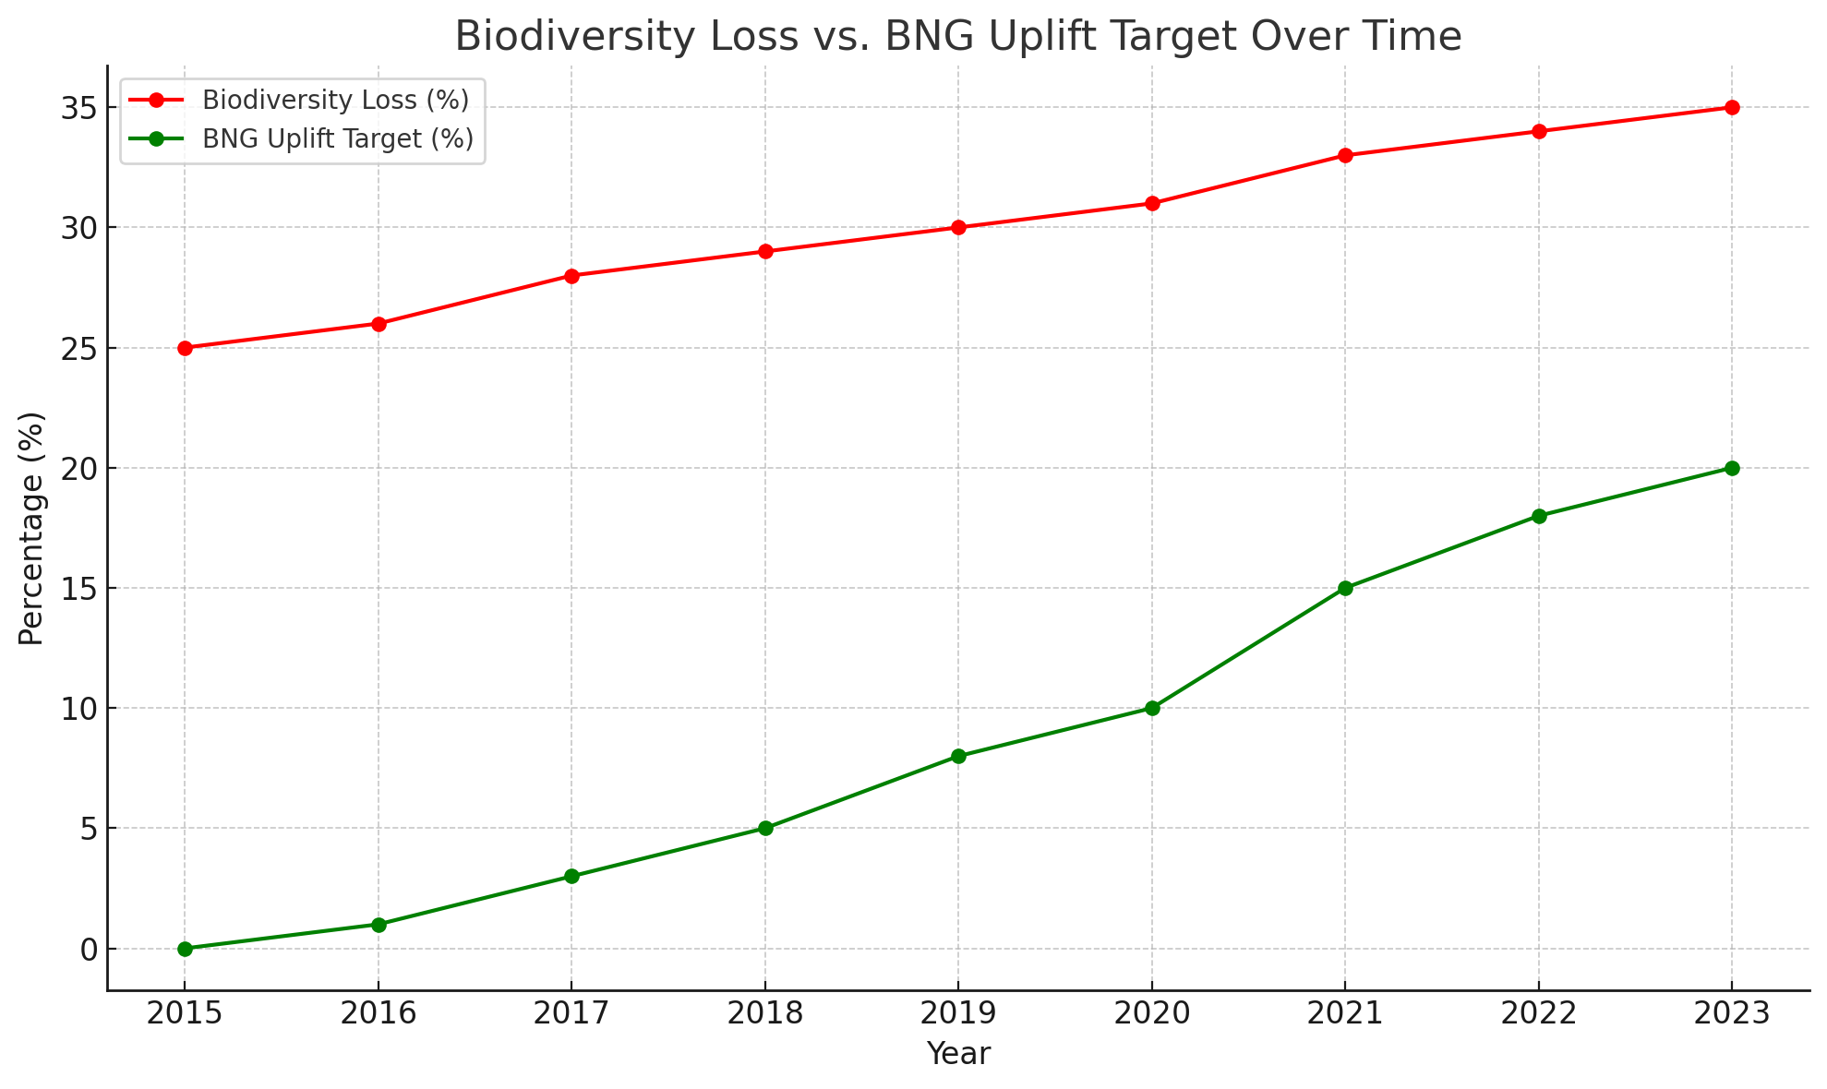

**Figure 6: Biodiversity Loss vs. BNG Uplift Target Over Time**

## Theoretical Frameworks

Theoretical foundation is grounded in several key theoretical frameworks that guide its approach to integrating biodiversity conservation with financial and spatial analysis. The Ecosystem Services Framework forms the cornerstone of this project, emphasizing the critical role of biodiversity in providing essential ecosystem services, such as clean air, water, and food. This framework justifies the financial investments made in habitat restoration and creation by linking these efforts to broader environmental and societal benefits.

Cost-Benefit Analysis (CBA) is another crucial framework, widely adopted in environmental economics to evaluate the financial viability of conservation projects (Azudin et al., 2024; Drèze & Stern, 1987). CBA allows for the quantification of trade-offs between different conservation actions, ensuring that resources are allocated efficiently to maximize biodiversity gains. In this project, CBA was instrumental in estimating the costs associated with achieving the 20% Biodiversity Net Gain (BNG) uplift in Surrey, including land purchase, habitat creation, and ongoing maintenance

Spatial Analysis and Geographic Information Systems (GIS) play a central role in the project, informed by theories of spatial ecology that highlight the importance of habitat connectivity for species survival(Krzanowski et al., 2024). The use of GIS allowed for the mapping and prioritization of areas for conservation, ensuring that interventions are both ecologically and economically sound. This approach facilitated the identification of key areas for habitat restoration and creation, crucial for achieving the BNG targets.

By integrating these theories, the project ensures that its strategies not only aim for biodiversity targets but also align with Surrey’s long-term sustainability goals. The Ecosystem Services Framework provides the rationale for conservation efforts, while CBA and spatial analysis translate these efforts into actionable strategies that are financially and ecologically sustainable.

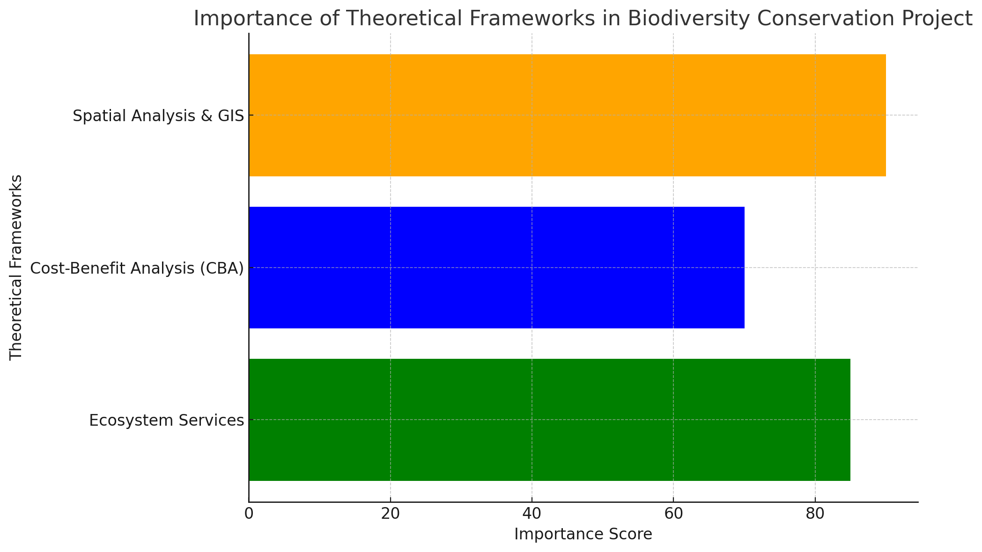

**Figure 7: Theoretical Frameworks in Biodiversity Conservation**

## Critical Evaluation

The Ecosystem Services Framework, Cost-Benefit Analysis (CBA), and Spatial Analysis theories are foundational to this project, providing essential tools for biodiversity conservation, financial modelling, and spatial planning. These frameworks complement each other but differ in their application to achieve the 20% Biodiversity Net Gain (BNG) uplift.

The Ecosystem Services Framework emphasizes the ecological value of biodiversity in delivering essential services like clean air, water, and food. This framework justifies habitat restoration and conservation by linking them to broader societal benefit. However, it may overlook economic feasibility, as discussed in studies that highlight the challenges of integrating ecosystem services into large-scale landscape restoration (Husain et al., 2024)​. Conversely, the Cost-Benefit Analysis model focuses on the financial viability of conservation actions, ensuring efficient resource allocation for the highest biodiversity returns. Yet, CBA can undervalue non-market benefits like ecosystem services, which are difficult to quantify monetarily (Lauvie et al., 2023).

Spatial Analysis, integrated with Geographic Information Systems (GIS), supports the spatial planning of conservation efforts, ensuring strategic habitat connectivity(Partha Protim Roy et al., 2024). Its strength lies in prioritizing conservation areas, though it can be resource-intensive due to data and tool requirements

(de Groot et al., 2022)

Among these theories, the Ecosystem Services Framework justifies the ecological value of the BNG uplift, while the CBA model addresses financial management. Spatial Analysis operationalizes these insights into actionable strategies, aligning ecological and economic goals. Integrating these frameworks positions the project to effectively meet its biodiversity and financial objectives.

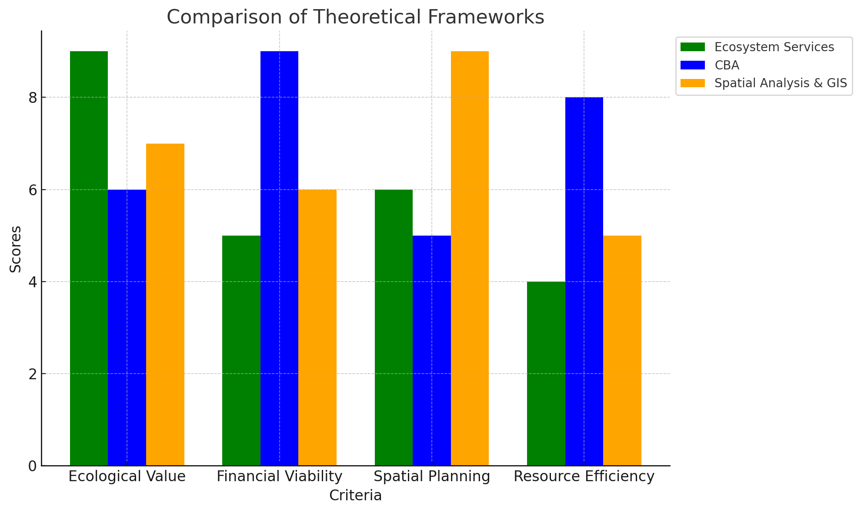

**Figure 8: Comparison of Theoretical Frameworks**

## Knowledge Gap and Insights Sought

Current knowledge lacks comprehensive integration of financial modelling with ecological and spatial analysis for targeted habitat restoration. This project seeks to bridge these gaps by offering insights into cost-effective resource allocation for achieving the 20% Biodiversity Net Gain (BNG) uplift in Surrey. By uniting financial, ecological, and spatial data, the project aims to develop strategies that are both economically viable and ecologically sustainable, effectively addressing the existing disconnect in conservation planning.

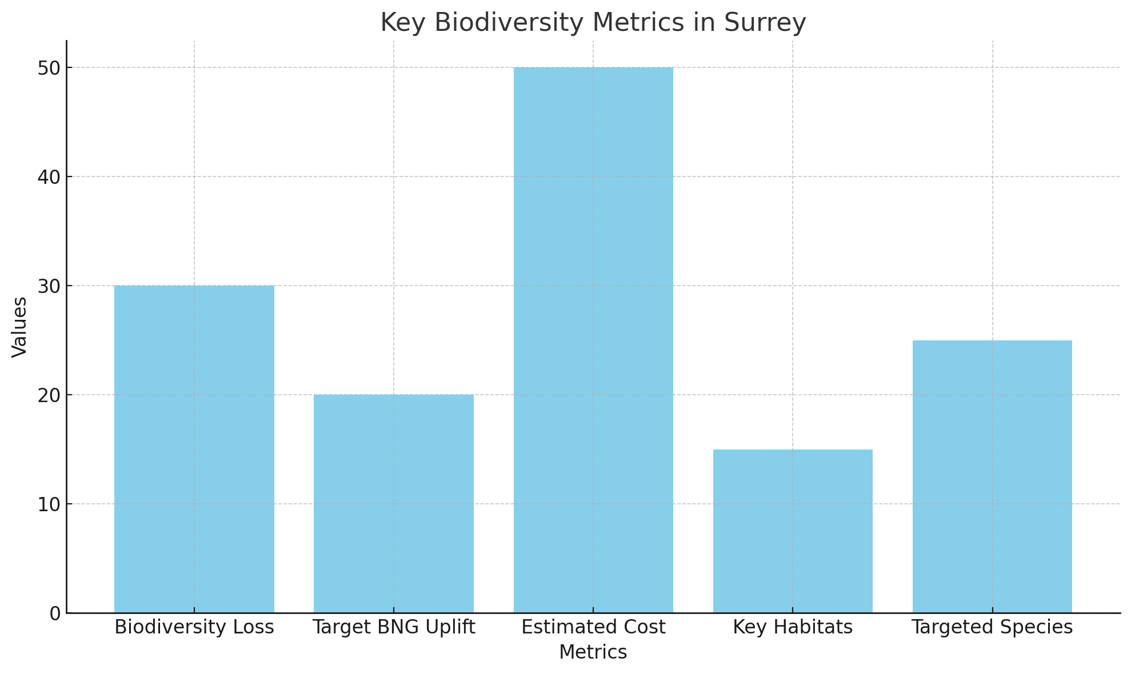

**Figure 9: Biodiversity Metrics in Surrey**

In conclusion, the integration of financial modelling, ecological evaluation, and spatial analysis is essential for advancing biodiversity conservation efforts. By addressing key limitations and knowledge gaps, these approaches can effectively guide initiatives like the 20% Biodiversity Net Gain uplift in Surrey, ensuring both ecological and economic sustainability.

# Analytical Framework and Method

A comprehensive understanding of the methodologies employed in this project, this section details the research approach, design, and ethical considerations that guided the analysis aimed at achieving a 20% Biodiversity Net Gain (BNG) in Surrey by 2030.

## Research Methodology

The research methodology for this project was primarily driven by the need to integrate financial modelling, ecological evaluation, and spatial analysis to achieve a 20% Biodiversity Net Gain (BNG) in Surrey by 2030. The chosen approach, which combines quantitative and spatial analytical techniques, is justified by the interdisciplinary nature of biodiversity conservation, where both ecological and economic factors must be considered. According to (Perschke et al., 2023), the Ecosystem Services Framework underpins the importance of preserving biodiversity by linking it directly to human well-being, thus justifying the financial investments required for habitat restoration and conservation. Furthermore, the use of Geographic Information Systems (GIS) for spatial analysis is well-supported in the literature, with studies like (Costanza et al., 2007)highlighting its effectiveness in identifying and prioritizing conservation areas based on habitat connectivity and species distribution.

The integration of financial, ecological, and spatial analyses is particularly appropriate for this project’s aim to achieve a 20% BNG uplift in Surrey. The financial modelling component addresses the objective of estimating the costs associated with achieving the BNG target, ensuring that resource allocation is both efficient and effective. This approach aligns with the work of (O’Mahony, 2021),who emphasize the importance of Cost-Benefit Analysis (CBA) in making informed decisions about conservation investments. The ecological evaluation ensures that the conservation efforts are ecologically sound, by identifying priority habitats and assessing their current state. Spatial analysis, supported by GIS tools, enables the precise mapping and prioritization of conservation areas, ensuring that interventions are not only effective but also strategically placed (Hou et al., 2024). This method ensures that the project’s strategies are grounded in a thorough understanding of Surrey’s ecological and financial landscape, making it well-suited to meet the project’s objectives(Prasai, 2022).

Alternative methods, such as purely qualitative approaches or those relying solely on financial analysis without spatial considerations, were deemed less suitable for this project(Dertien and Baldwin, 2023). A purely qualitative approach, while valuable in understanding stakeholder perspectives, would not provide the quantitative rigor needed to estimate costs or assess ecological impacts accurately. Similarly, a financial analysis devoid of spatial context might fail to address the critical aspect of habitat connectivity, which is essential for species survival as highlighted in spatial ecology literature(Lai and Zoppi, 2024).

In contrast, the chosen method of integrating financial modelling, ecological evaluation, and spatial analysis provides a more comprehensive framework(Wahl et al., 2024). It allows for a nuanced understanding of the trade-offs involved in conservation efforts, ensuring that financial investments are directed towards areas where they will have the most significant ecological impact. This integrated approach, supported by both quantitative and spatial data, is therefore the most suitable for achieving the project’s aim and objectives.

In summary, the chosen research method is well-supported by the literature and is particularly suited to the interdisciplinary nature of biodiversity conservation projects. By integrating financial, ecological, and spatial analyses, the methodology ensures that the project not only meets its biodiversity targets but does so in a manner that is both economically viable and ecologically sound. This comprehensive approach is more effective than alternatives, providing a robust framework for achieving the 20% BNG target in Surrey by 2030(Biodiversity Opportunity Areas: Surrey Nature Partnership, 2019).

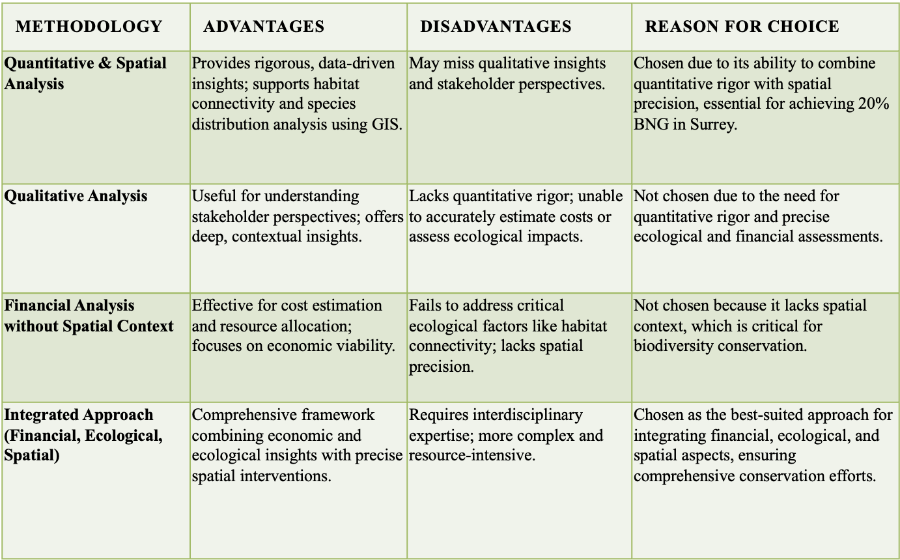

**Figure 10: Methodology**

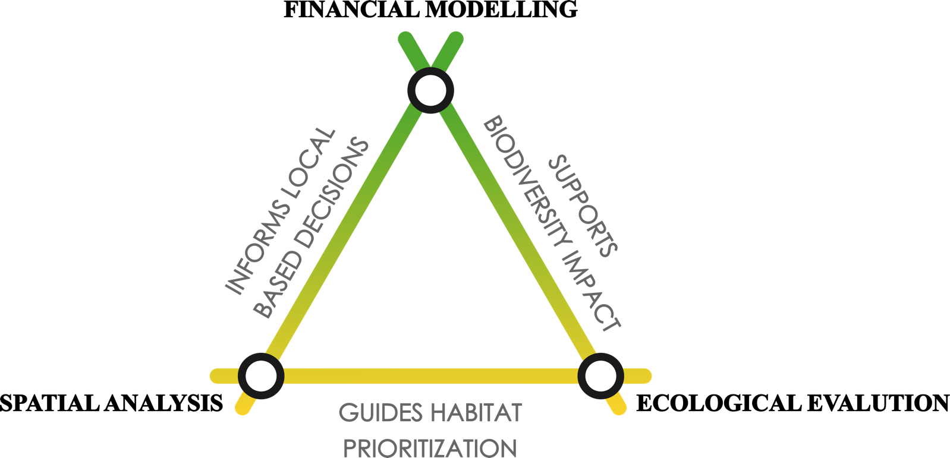

**Figure 11: Reflective Framework**

## Research Design

The research design is carefully structured to analyse the financial and ecological aspects of the BNG uplift with a focus on species protection. The research follows a clear and systematic process:

1. **Data Collection**: Data was sourced from the Surrey Wildlife Trust, DEFRA Magic Map Tool, and HM Land Registry, ensuring accuracy and reliability in habitat area measurements and land value estimations.
2. **Data Pre-Processing**: Data was cleaned and standardized to prepare it for analysis. This included calculating the 20% uplift in habitat areas and adjusting the financial projections for inflation.
3. **Cost Calculation**: Detailed estimations were made for land purchase, habitat creation, restoration, and maintenance. The calculations were adjusted to include a 2.2% inflation rate, ensuring that the financial forecasts are accurate through 2030.
4. **Review & Adjustments**: The research design includes a review phase where initial cost estimates are periodically adjusted based on the latest data and trends.
5. **Output and Reporting**: The final output consists of detailed reports and visualizations, created using Power BI, to communicate the findings effectively to conservationists and stakeholders focused on species protection.

Challenges, such as the manual calculation of habitat areas, were addressed through rigorous data validation and cross-referencing with reliable sources. Tools like Python and Excel were employed for data analysis, ensuring accuracy and clarity in the findings. Please find the analytical framework below (Fig:12)

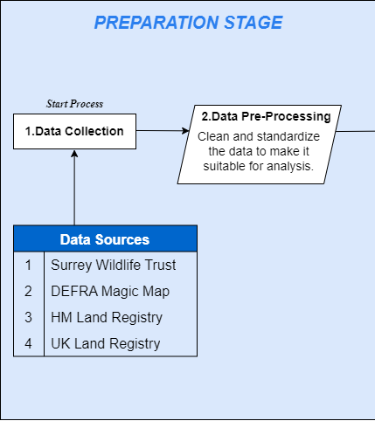

**Figure 12: Analytical Framework- Preparation Stage**

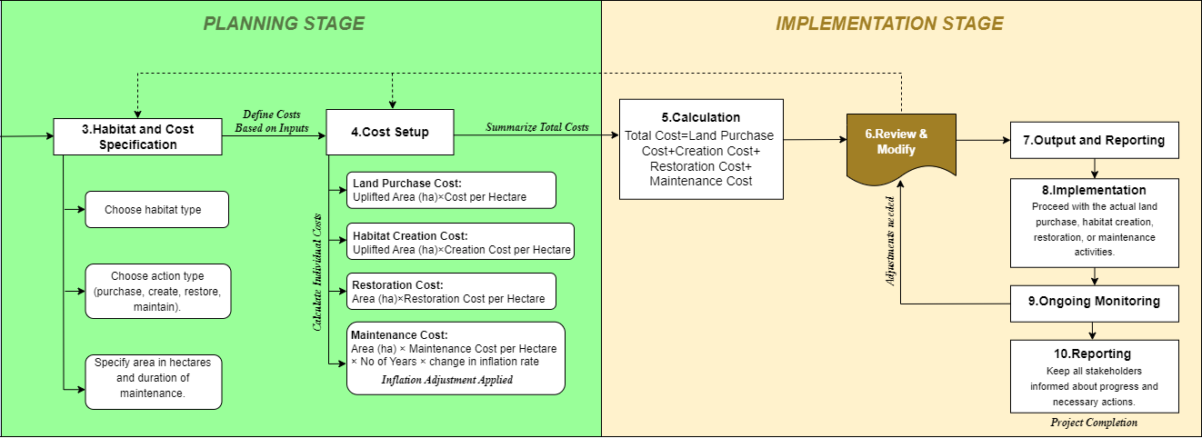

**Figure 13: Analytical Framework - Planning & Implementation Stage**

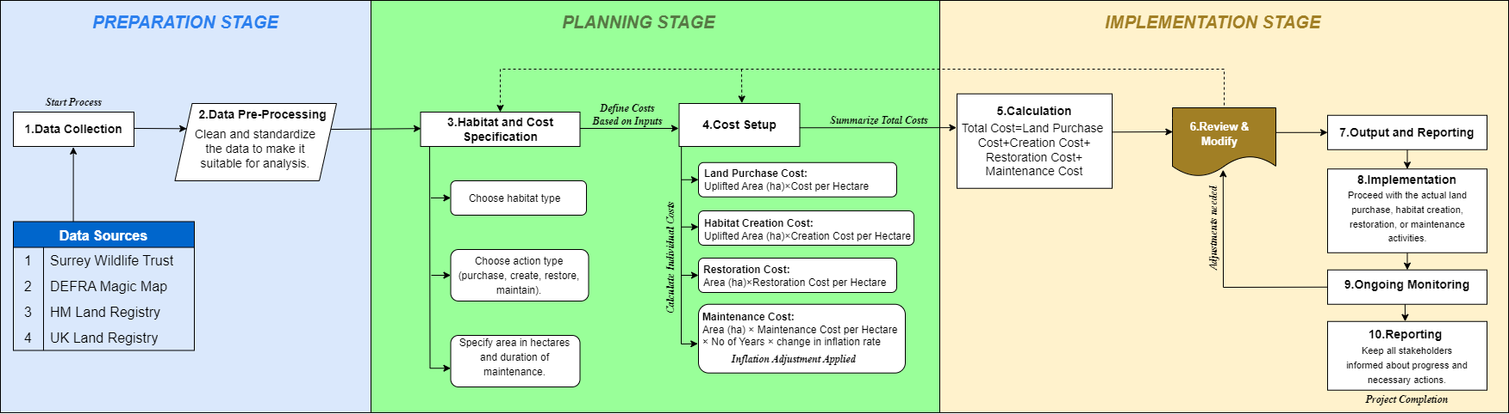

**Figure 14: Analytical Workflow**

## Ethical Considerations

Ethical considerations were a vital aspect of this research, especially given the emphasis on species protection and biodiversity conservation. Ethical approval was obtained from Royal Holloway University of London, ensuring that the research was conducted in accordance with the highest ethical standards.

Measures were put in place to safeguard the privacy and anonymity of all participants, with strict compliance with GDPR regulations. Informed consent was secured where necessary, ensuring that all parties involved were fully informed about the research objectives and methods. The research also adhered to specific ethical guidelines related to the protection of endangered species and the conservation of natural habitats.

Furthermore, the research was conducted with a strong awareness of its potential impact on conservation efforts. The findings were handled responsibly, with careful consideration of their implications for species protection initiatives in Surrey. The data from the findings is an open0source data. The goal was to ensure that the research would support ongoing conservation work and contribute to the preservation of Surrey’s biodiversity.

# The Data

The data-related aspects of this project are meticulously detailed to ensure accuracy and relevance in assessing Surrey's Biodiversity Net Gain (BNG) uplift, with a strong focus on species protection.

## Data Description

The Uplifted BNG Data includes both spatial and fiscal moulding needed for biodiversity management and conservation planning in Surrey. This dataset covers calculated areas for various important habitats. They are essential for assessing the viability and consequences of reaching a 20% increase in biodiversity net gain (BNG), with a focus on species protection. Data was gathered from reliable sources such as the DEFRA Magic Map Tool, Surrey Wildlife Trust, and the UK Land Registry and HM Land Registry. Precise cost calculations are the foundation for monetary projections and ecological studies. This data is crucial for identifying key habitats that need conservation. The dataset includes variables like Habitat Type, Current Area (ha), 20% Uplifted Area (ha), Total New Area (ha), Creation Cost per Hectare, Restoration Cost per Hectare, Maintenance Cost per Hectare/Year, and Land Purchase Cost per Hectare. By using the most current land development records, this dataset ensures that the analysis is both relevant and accurate, particularly for species protection.

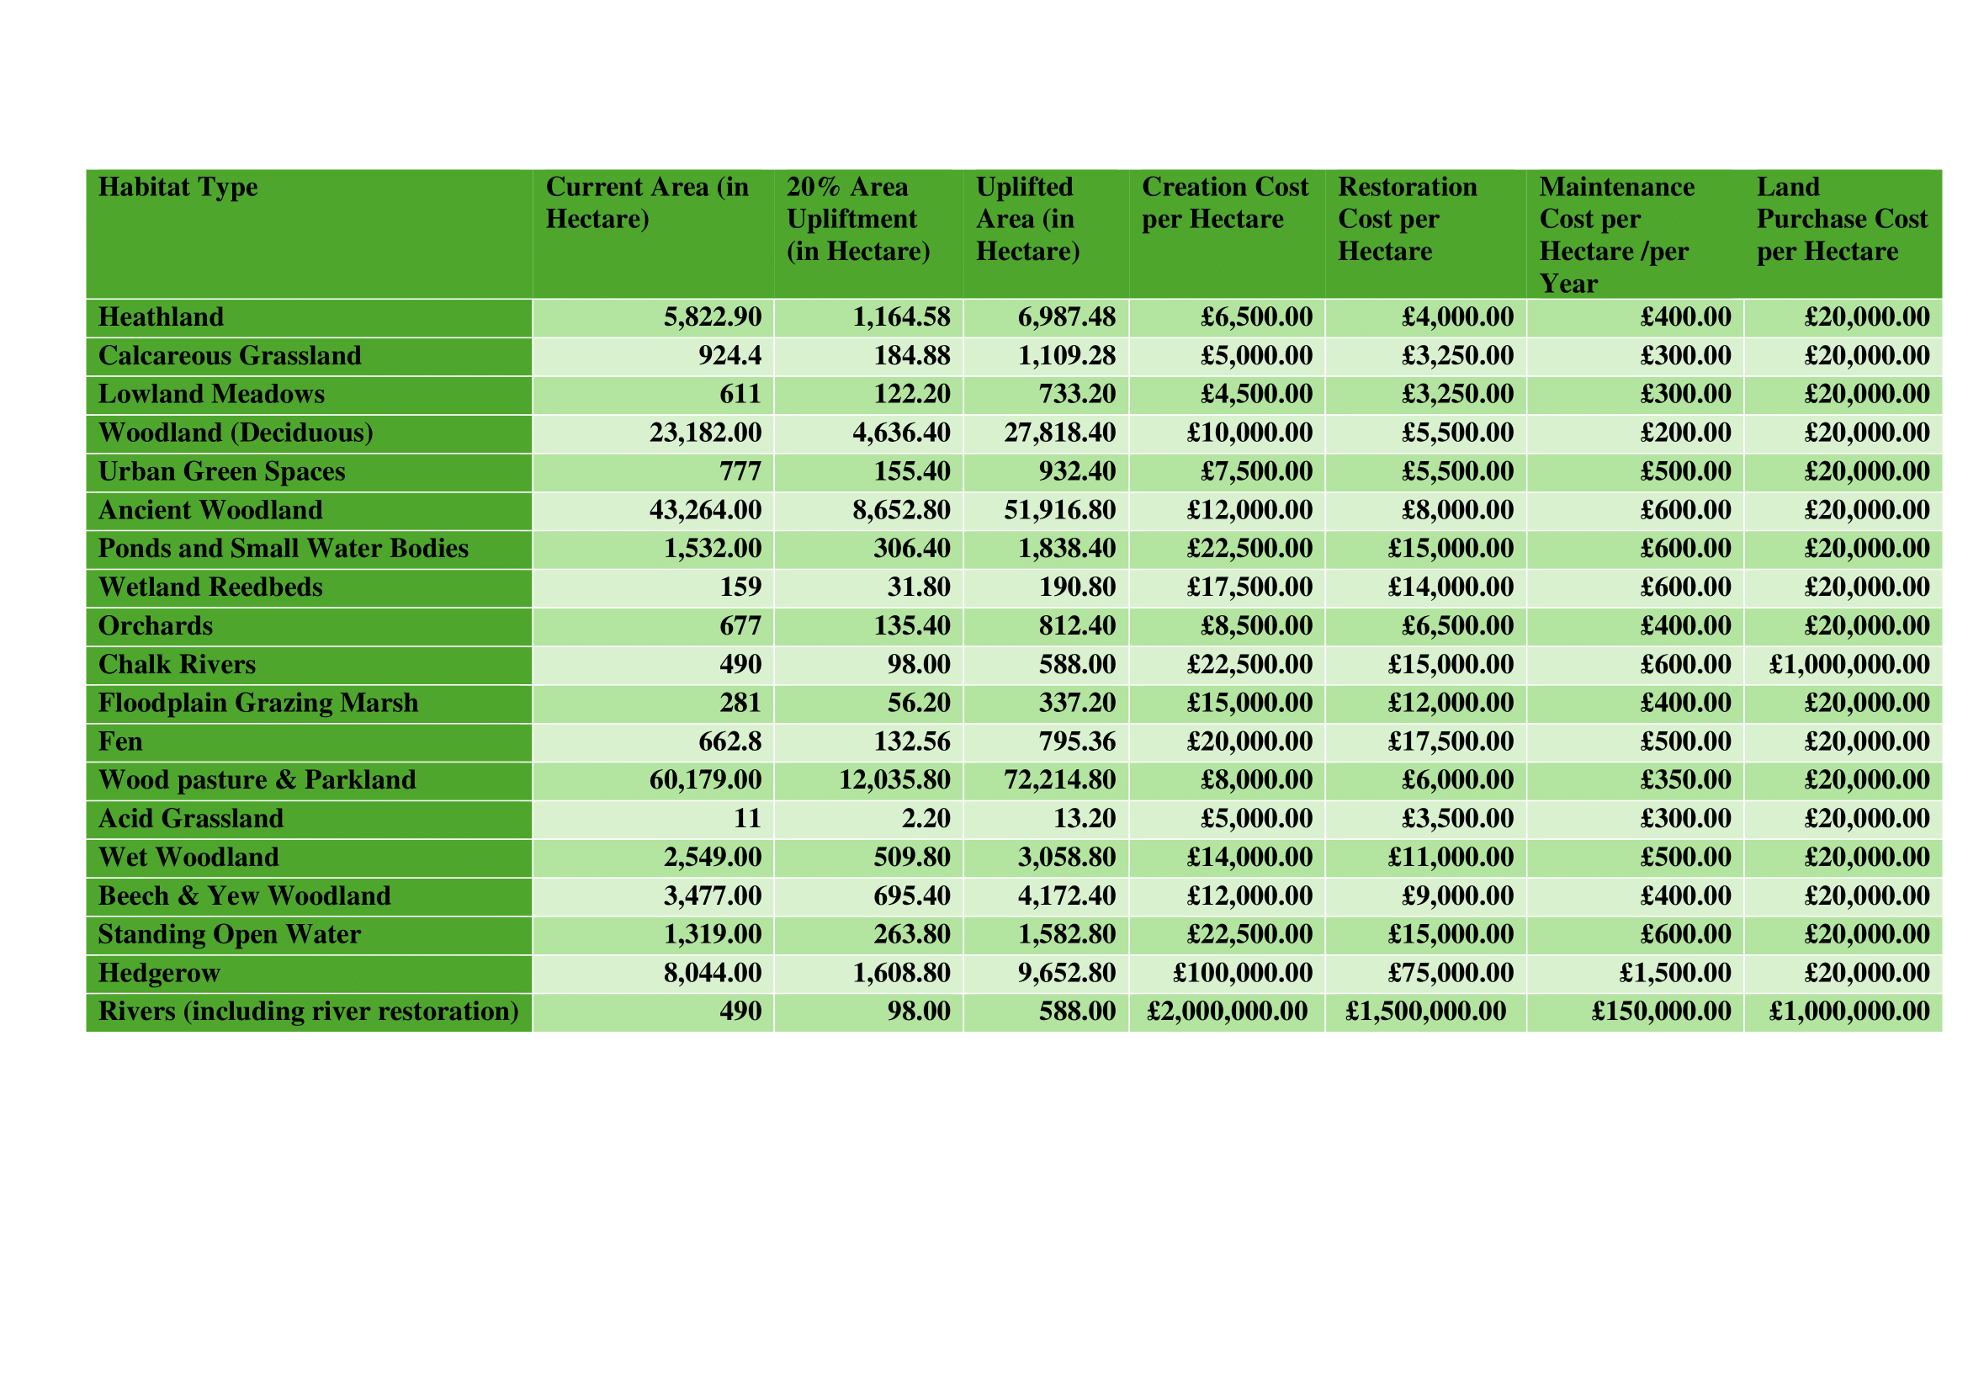

**Figure 15: Cost Data for Habitat Uplift**

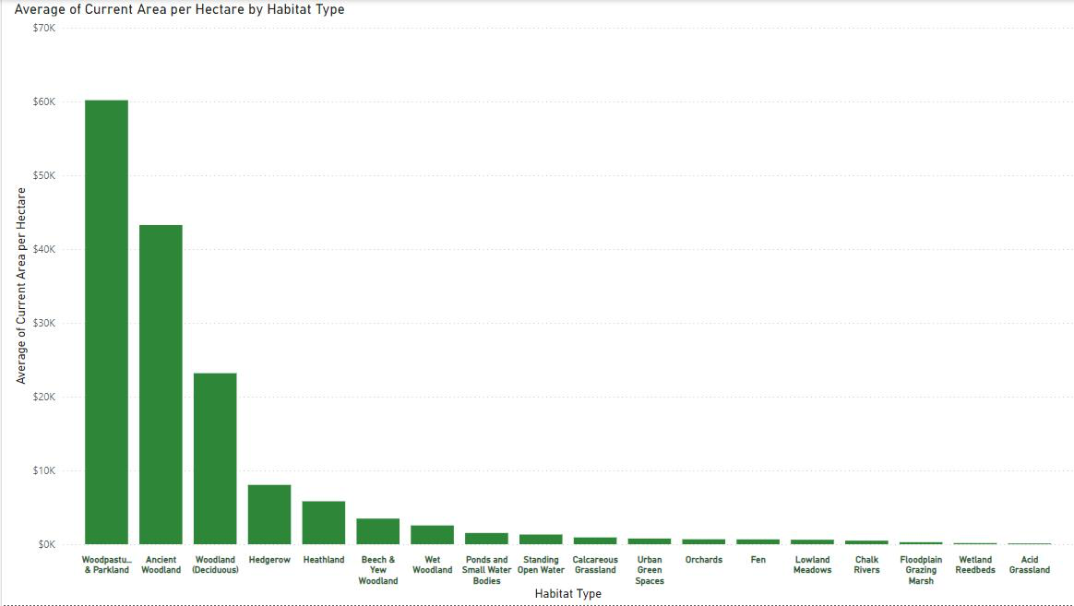

**Figure 16: Current Area by Habitat Type**

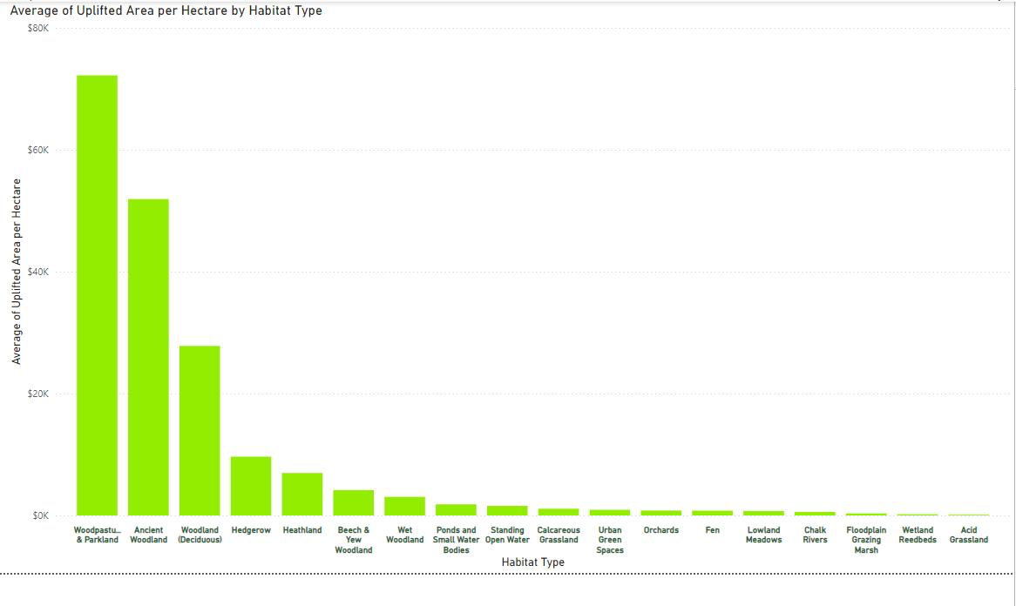

**Figure 17: Uplifted Area by Habitat Type**

## Source Justification

The choice of data sources was guided by the need for precision, reliability, and appropriateness to the research objectives. This was especially important for species conservation. The DEFRA Magic Map Tool was selected for its detailed spatial data on land use and habitat types. It provides authoritative geographic information essential for accurate environmental analysis. Stats from the Surrey Wildlife Trust offered crucial local biodiversity insights. These insights reflect specific conditions in Surrey, which directly impact species protection. The UK and HM Land Registries provided vital data on land transactions. This data is key for accurate financial modelling of land purchase costs related to habitat preservation.

These sources are highly credible, managed by reputable institutions like DEFRA and the respective Land Registries. This ensures that the data is reliable and regularly updated. Alternative sources, such as commercial GIS platforms and global biodiversity datasets, were considered but not used. These alternatives lacked the necessary specificity for the UK context and could introduce potential biases. The selected sources provided the needed level of intricacy and dependability. without the limitations of commercial data providers. However, potential biases could stem from the temporal scope of the datasets or recent changes in land use not yet captured. To address this, the most recent datasets were used, and data was cross-referenced with DEFRA to ensure coherence. The land value per hectare used in financial analysis was generalised, which might introduce variability in Surrey’s land cost estimates, especially in areas crucial for species protection.

## Data Preparation

Data preparation was crucial to ensure the accuracy and relevance of the analysis, particularly for species protection. The process started with extracting and gathering spatial data using the UK’s Magic Map. Here, distinct habitat zones critical for species survival were identified and calculated. The data was then prepared into a comprehensive dataset in Excel. This dataset included variables like Habitat Type, Current Area (ha), and various cost metrics, forming the foundation for further analysis focused on species conservation.

An exhaustive cleanup method was conducted to tackle discrepancies, such as duplicate entries or divergences in area measurements. Missing data was carefully reviewed and cross-referenced with additional datasets from the Surrey Wildlife Trust and DEFRA. Where consistent data was not available, the dataset was highlighted but retained to ensure comprehensiveness. After cleaning, the data was transformed by calculating a 20% uplift for each habitat type, a crucial metric for the project aimed at enhancing species protection. The increase in 20% uplift helped in recalculating the financial calculations for Surrey BNG. These computations encompassed expenditures for habitat creation, restoration, maintenance, and land purchase. This process converted manually calculated area data into actionable financial metrics.

The manual extraction process from the DEFRA’s Magic Map posed significant challenges. These required meticulous attention to detail. Discrepancies across different sources were resolved by cross-referencing with additional data from DEFRA, ensuring the figures were accurate and relevant to species protection efforts. These challenges were managed through a rigorous data validation process and by consulting multiple sources to ensure reliability. The final dataset represents a comprehensive compilation of habitat categories, regions, and related prices. It provides a strong groundwork for the analysis conducted in this project, focusing on protecting Surrey’s most vulnerable species.

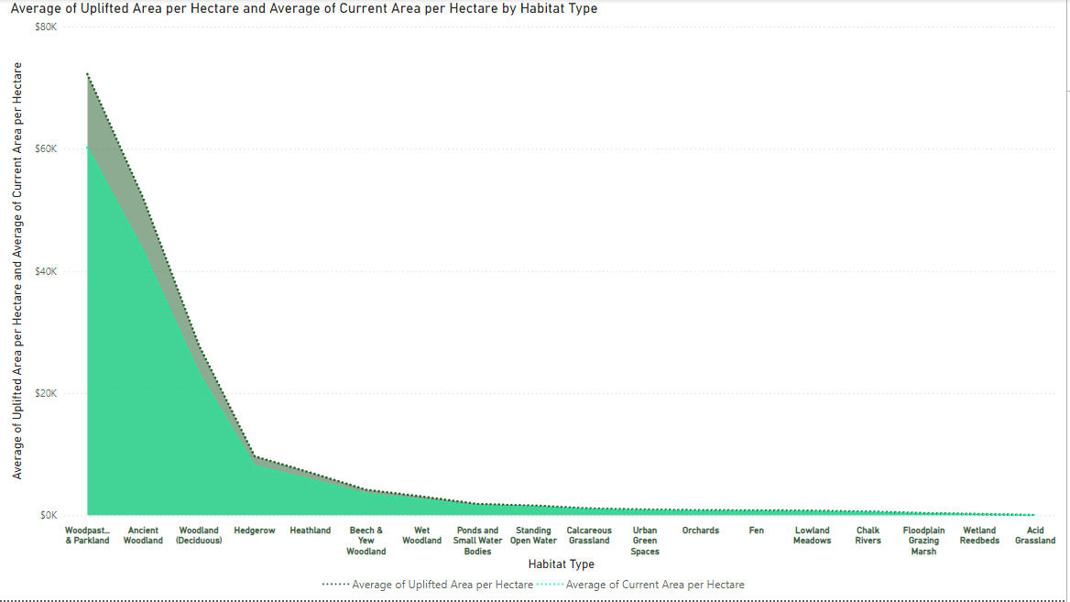

**Figure 18: Average of Uplifted Area per Hectare and Average of Current Area per Hectare by Habitat Type**

## Data Assumptions and Limitations

Several assumptions were made during the analysis, with an awareness of the limitations of the data, especially in species protection. One key assumption was applying a tolerance of plus or minus 10 hectares to account for minor inaccuracies in habitat area measurements. This was particularly necessary during manual extraction. This adjustment was made to address challenges related to precise mapping, especially in habitats crucial for species survival. The AI model used for calculating habitat areas from pixelated images was assumed to provide predictions accurate enough for this analysis. However, the model's accuracy depends on the quality of the training data, which could introduce variability. Additionally, the land value per hectare used in financial modelling was generalised based on industry standards. The assumption was that these generalised values are representative of actual costs, though local variations, particularly in areas critical for species protection, may exist.

The main limitation identified was the accuracy of area measurements derived from the DEFRA Magic Map Tool. While the tool is invaluable, the manual extraction process and inherent mapping resolution limitations introduced some inaccuracy. Additionally, reliance on generalised cost data for activities like land purchase, habitat creation, and maintenance may not fully capture local variations in Surrey. This could affect the accuracy of financial projections related to species protection.

To mitigate these limitations, the strategies were implemented to address and ensure that the analysis provides a reliable basis for decision-making regarding the BNG uplift in Surrey, particularly in safeguarding the region’s most vulnerable species.

# The Analysis

The analysis process undertaken in this study is multifaceted, involving **descriptive, diagnostic, predictive, and prescriptive analytics** to inform strategies for species protection and habitat restoration. The primary goal was to assess the current state of biodiversity in Surrey, forecast the financial requirements for achieving a 20% uplift in biodiversity by 2030, and prescribe optimal strategies for habitat creation, restoration, and maintenance. Python was used for data processing and cost projections, Excel facilitated initial data cleaning and organization, and Power BI was essential for advanced data visualization and geospatial analysis. These tools provided the foundation for an in-depth exploration of the data, facilitating the identification of key trends, patterns, and areas for ecological improvement.

## Analysis Progression

The overall strategy of this analysis was designed to assess current biodiversity levels in Surrey, predict financial requirements for achieving a 20% Biodiversity Net Gain (BNG) by 2030, and identify areas that require restoration, maintenance, or creation. Additionally, the analysis aimed to determine which habitats could thrive in specific locations, ensuring optimal biodiversity protection.

The analysis aimed to quantify the ecological and financial implications of achieving a 20% BNG uplift in Surrey, focusing on habitat creation, restoration, and long-term maintenance. This involved a comprehensive approach that combined various analytical techniques to provide actionable insights for stakeholders. The analysis also aimed to align with Surrey's conservation goals, ensuring that the proposed BNG uplift supports the region's long-term sustainability objectives.

The analysis followed a logical sequence, starting with descriptive analytics to understand the baseline conditions of habitats and their associated costs. This was followed by diagnostic analytics to explore the factors driving observed trends and identify potential causal relationships. Predictive analytics were then employed to forecast future habitat areas and financial needs, culminating in prescriptive analytics to recommend strategies for achieving the BNG targets efficiently.

Descriptive analytics was the foundation of the analysis, providing the necessary context and baseline data. The insights gained from this stage informed the diagnostic phase, where deeper analysis helped to identify the causes behind observed patterns. The diagnostic findings, in turn, shaped the predictive models, ensuring that the forecasts were grounded in an understanding of key drivers. Finally, prescriptive analytics offered actionable recommendations, integrating insights from all previous stages to propose a feasible and effective plan for biodiversity enhancement.

To conduct the analysis, a combination of Python, Microsoft Excel, and Power BI was employed. Python was used for data processing and initial cost projections, Excel facilitated data cleaning and preliminary analysis, while Power BI was crucial for advanced data visualization and geospatial analysis. These tools collectively enabled a thorough and accurate analysis, ensuring that the findings were both insightful and actionable.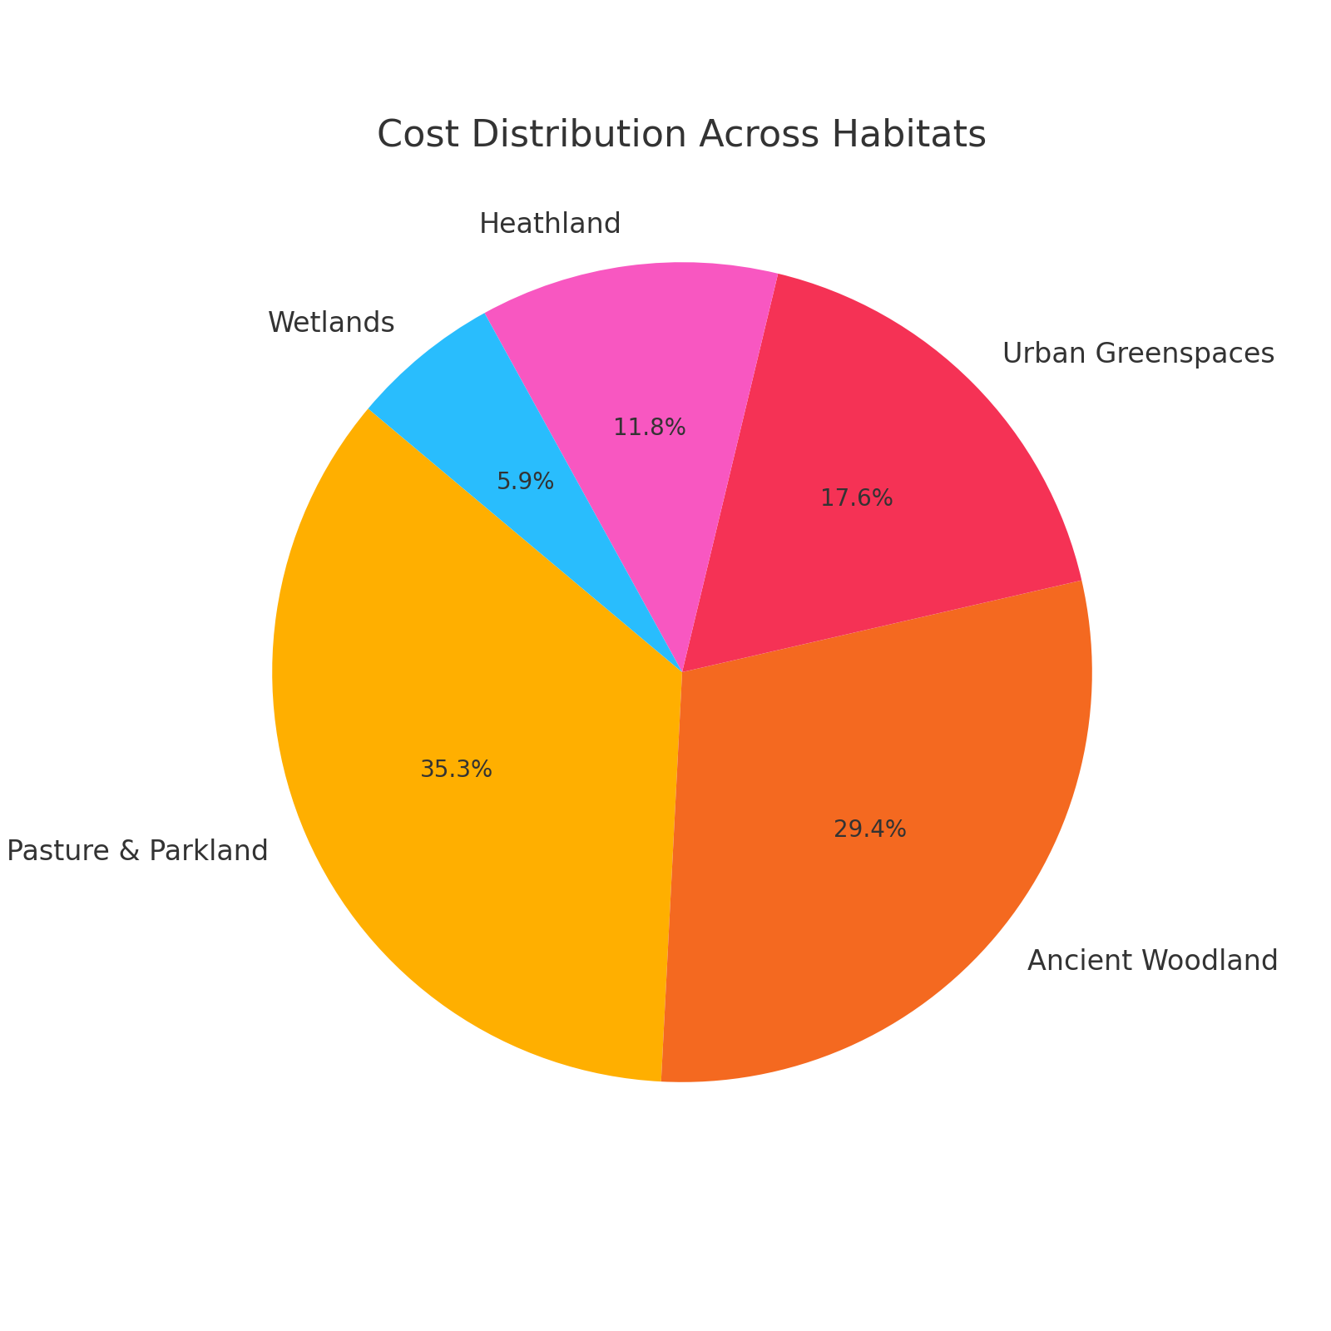

Figure 19: Cost Disertation

## Descriptive Analytics

The preliminary investigation of the dataset focused on understanding the distribution of various habitat types across Surrey, the current areas these habitats cover, and the associated costs for their maintenance and potential expansion. The key metrics analysed included the current area each habitat type covers and the associated costs for their maintenance and potential expansion. The primary variables examined were habitat type, current area in hectares, and costs related to land purchase, habitat creation, restoration, and maintenance.

Python was used for data processing and advanced cost projections, Excel facilitated initial data cleaning and organization, and Power BI was utilized for creating dynamic visualizations and conducting geospatial analysis. These tools provided a robust framework to explore and interpret the data, ensuring accurate and actionable insights were generated.

The descriptive analysis revealed that Wood pasture & Parkland and Ancient Woodland are the most extensive habitats, covering approximately 72,000 and 52,000 hectares, respectively. These habitats are not only large in area but also incur the highest costs, particularly for land purchase and restoration. This finding is critical as it highlights the significant investment required for their conservation.

Unexpected patterns emerged, such as the high cost per hectare for maintaining smaller habitats like Wet Woodland, which, despite their size, play a significant role in maintaining biodiversity. Despite their limited area, these habitats play a significant role in maintaining biodiversity, particularly in supporting specific species that rely on these unique environments. Additionally, the analysis showed that some habitats, though large, were highly disintegrated, posing challenges for their ecological connectivity.

The visualizations included in this section, such as bar charts and pie charts, effectively illustrate these findings. For example, the Average of Uplifted Area per Hectare by Habitat Type chart highlights the financial burden posed by different habitat types. The Current Area vs. 20% Uplift chart visually contrasts the current habitat areas with the projected areas needed to achieve the 20% Biodiversity Net Gain (BNG) uplift, clearly showing the areas that require the most attention and investment.

In summary, the descriptive analysis provided a detailed overview of Surrey's habitat landscape, identifying key trends and anomalies that will guide further analysis and conservation efforts. The insights gained here form the foundation for the subsequent stages of the analysis, ensuring that conservation strategies are both data-driven and cost-effective.

## Diagnostic Analytics

The diagnostic analysis aimed to delve deeper into understanding the underlying factors that influence habitat distribution and associated costs in Surrey. This analysis focused on identifying the causal relationships between habitat characteristics and the financial implications of their conservation.

To understand why certain patterns or trends occurred, techniques such as correlation analysis and regression models were employed. Correlation analysis revealed strong relationships between habitat size and species survival rates, particularly in larger habitats like Wood pasture & Parkland. Regression models quantified the impact of financial investment on biodiversity outcomes, showing that higher investment in habitat restoration led to better outcomes in terms of species protection and habitat quality.

Geospatial analysis played a crucial role in the diagnostic phase, allowing for the mapping and visualization of habitat distribution and fragmentation across Surrey. This analysis provided insights into the spatial relationships between habitats and land use intensity, further informing the understanding of biodiversity trends. By overlaying habitat data with land use patterns, the analysis identified key areas where habitat restoration would be most effective, highlighting regions where connectivity could be improved to support species movement.

Vital factors examined included habitat size, financial investment, land use intensity, and habitat quality. These factors were critical in understanding the drivers behind biodiversity trends. The analysis showed that habitat fragmentation, particularly in areas of high land use intensity, was a major contributor to species decline. The findings suggested that larger, more connected habitats were generally more resilient and supported higher biodiversity levels.

The analysis also revealed that greater financial input resulted in better ecological outcomes, though it also noted the substantial challenges associated with restoring fragmented habitats. These areas often required extensive efforts to re-establish connectivity and achieve ecological stability, leading to higher associated costs.

The diagnostic analysis confirmed that larger, more connected habitats were more resilient and supported higher biodiversity levels. Financial investment was found to be a critical driver of successful habitat restoration, with more funds leading to better outcomes. However, the analysis also identified significant challenges, such as the high costs associated with restoring fragmented habitats, which require more extensive efforts to achieve connectivity and ecological balance.

The relationships identified were statistically significant and validated through cross-validation and comparison with external data, confirming the robustness of the findings.

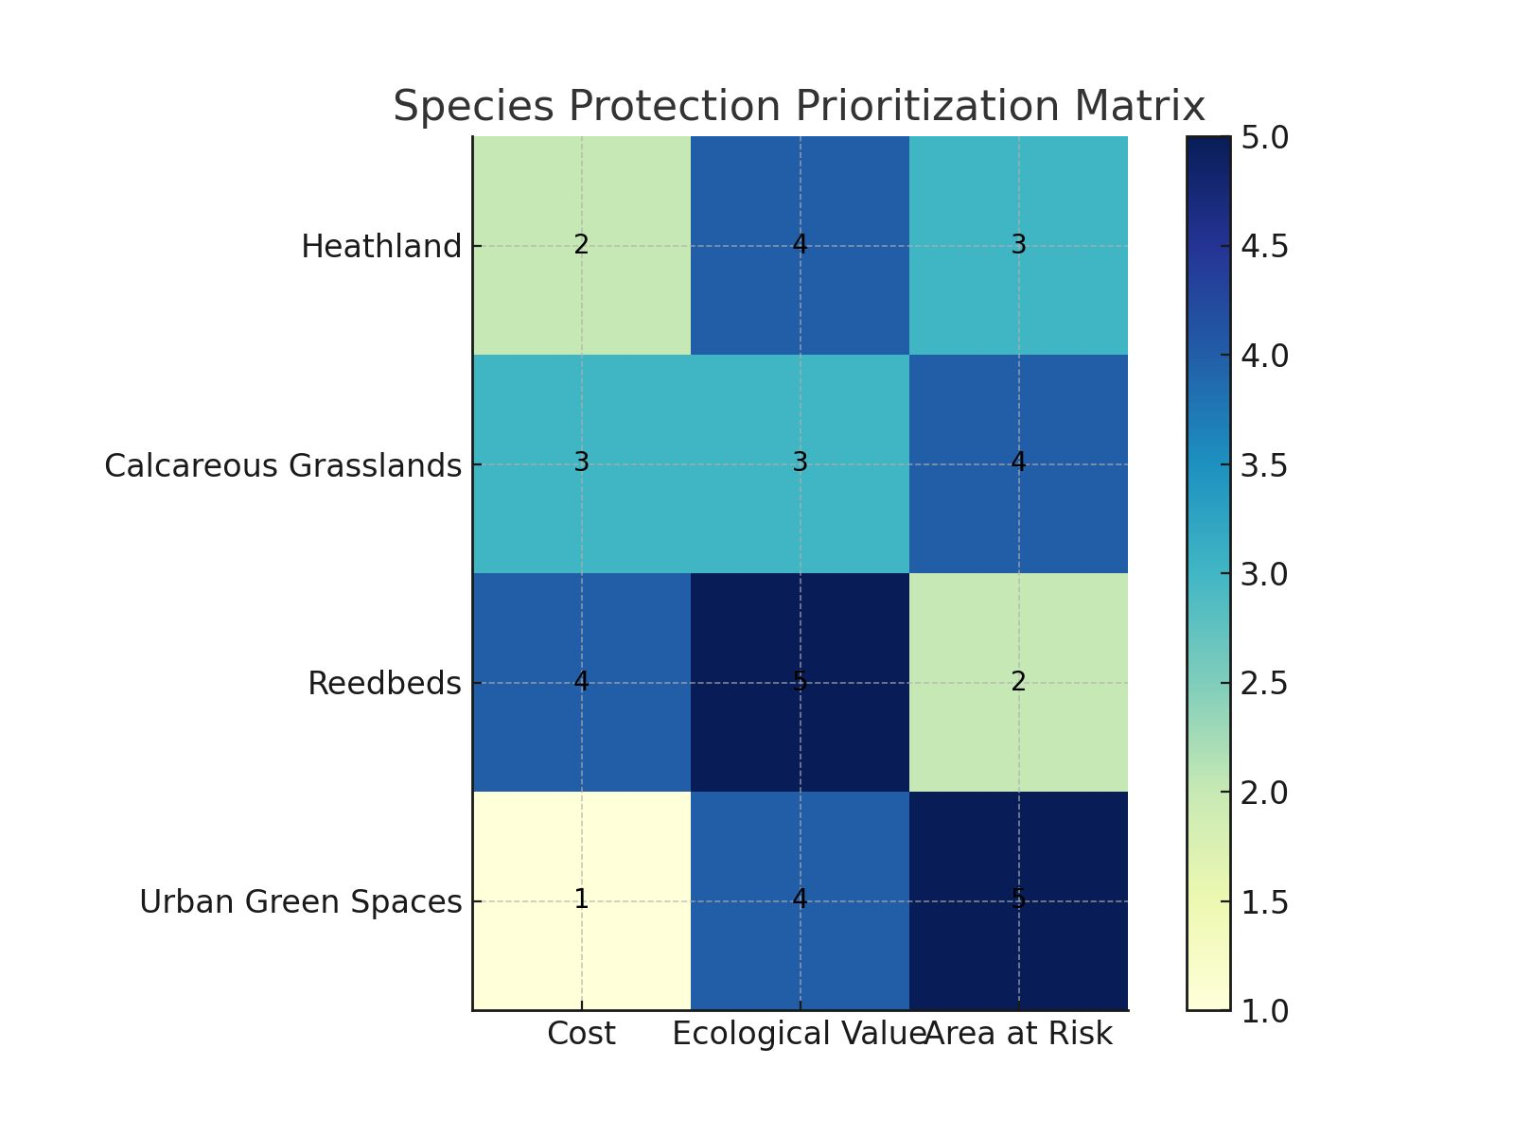

**Figure 20: Correlational Analysis**

## Predictive Analytics

The predictive analytics phase focused on forecasting the financial requirements to achieve the 20% BNG by 2030.

This phase employed models such as linear regression and time-series forecasting, which were chosen for their effectiveness in projecting future trends based on historical data and current trajectories. Cost projections were made using historical data and adjusted for inflation, providing a clear view of the financial landscape for the next decade.

Significant points selected for prediction included the current habitat area, uplifted area, and costs for creation, restoration, and maintenance. The assumption of a 2.2% annual inflation rate was used to project future costs, ensuring the estimates were realistic and aligned with economic trends. These projections also considered potential fluctuations in key economic variables, such as land values, to provide a more comprehensive understanding of the financial commitments required.

The results indicated that achieving the BNG targets would require significant financial investment, particularly for large habitats like Wood pasture & Parkland and Ancient Woodland. The projected costs for these habitats alone were substantial, highlighting the need for strategic planning and possibly external funding to bridge the financial gap. The analysis also revealed the uneven distribution of financial needs across different habitats, with smaller habitats like Wet Woodland presenting higher costs per hectare relative to their size.

The accuracy of these predictions was evaluated through cross-validation with historical data and sensitivity analysis. Sensitivity analysis tested the robustness of the models by simulating various economic scenarios, including potential changes in inflation and land purchase costs. While the models were robust, they were sensitive to changes in key variables like land purchase costs, suggesting that these factors could significantly impact the overall feasibility of the BNG targets. While the models were robust, they were sensitive to changes in key variables like land purchase costs, suggesting that these factors could significantly impact the overall feasibility of the BNG targets.

The predictive analysis built on insights from the descriptive and diagnostic phases, ensuring that the forecasts were not only financially accurate but also ecologically sound, providing a comprehensive view of the future challenges and opportunities in biodiversity conservation.

This integration of insights across different phases strengthened the reliability of the predictions, though ongoing monitoring and model adjustments will be necessary as new data emerges.

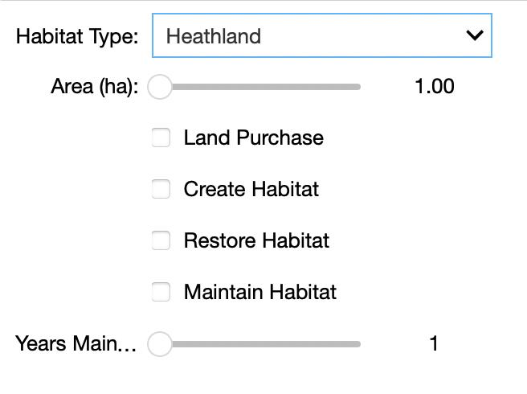

**Figure 21: Dashboard**

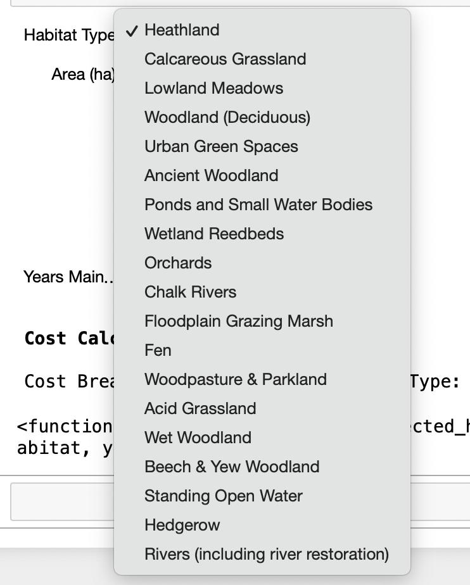

**Figure 22: Dashboard Dropdown**

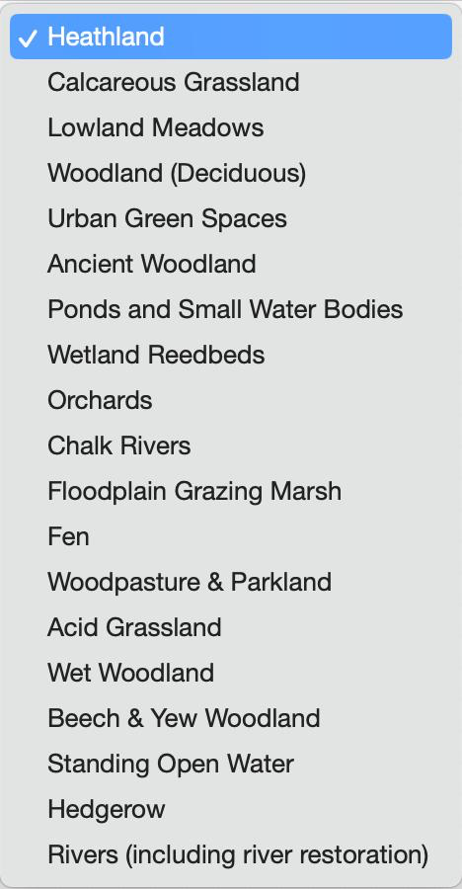

**Figure 23: Habitat List**

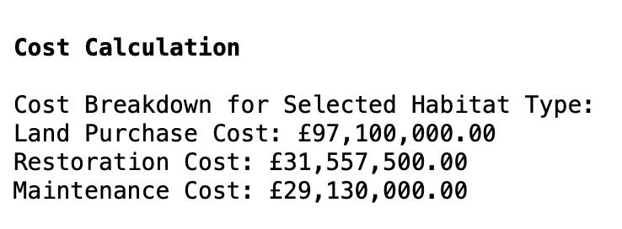

Figure 24: Cost Output

## Prescriptive Analytics

The final phase of the analysis centred on developing practical strategies to meet Surrey’s ambitious 20% Biodiversity Net Gain (BNG) targets by 2030. This stage involved translating the insights gained from previous analyses into concrete, implementable actions. The approach was rooted in optimizing resource allocation, focusing on habitats and species that would yield the highest conservation returns.

To guide these efforts, advanced optimization techniques, such as linear programming, were employed. Linear programming was particularly useful in balancing the allocation of limited resources across multiple conservation priorities, ensuring that the most critical areas received attention first. This allowed for the identification of the most cost-effective actions under varying financial constraints. Scenario planning also played a crucial role, helping to model the impact of different levels of investment on biodiversity outcomes. This method ensured that the proposed strategies were adaptable to shifts in funding or ecological priorities.

The analysis highlighted specific habitats, like Wet Woodland and Hedgerows, as immediate priorities for restoration due to their high levels of degradation. Starting restoration efforts in these areas is expected to generate significant, rapid improvements in biodiversity. The phased approach was recommended as a practical strategy, enabling Surrey Wildlife Trust to begin restoration in the most critical areas first, with plans to scale up as additional resources are secured.

Another key recommendation was the establishment of a comprehensive biodiversity monitoring framework. This framework would incorporate both remote sensing technology and on-the-ground surveys to provide a detailed, real-time overview of habitat health and species populations. This system would be essential for tracking the effectiveness of conservation efforts over time, providing data that could inform future management decisions and adjustments. The ongoing monitoring would ensure that the strategies remain responsive to ecological changes and emerging threats.

Additionally, the project recommended the implementation of targeted species recovery programs. These programs would focus on species that are most at risk in Surrey, particularly those that play a crucial role in maintaining ecosystem health. By concentrating resources on these key species, the programs aim to secure their survival and, by extension, the overall health of the region’s ecosystems.

These strategies were thoroughly tested through various scenarios to confirm their feasibility and resilience. Sensitivity analyses were conducted to assess the potential impact of economic fluctuations, such as changes in land value or funding availability, on the success of these strategies. The integration of insights from the descriptive, diagnostic, and predictive phases ensured that the recommendations are grounded in a comprehensive understanding of Surrey’s unique ecological and financial landscape. The outcome is a strategic plan that not only aims to meet the BNG targets but also supports the long-term sustainability of Surrey’s natural habitats.

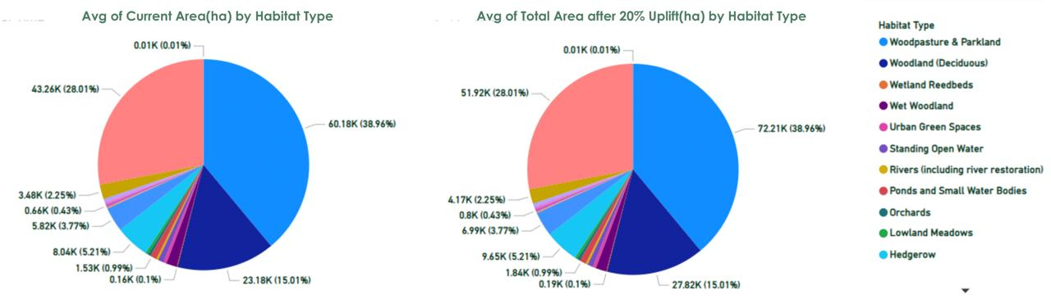

**Figure 25: Avg Area Habitat**

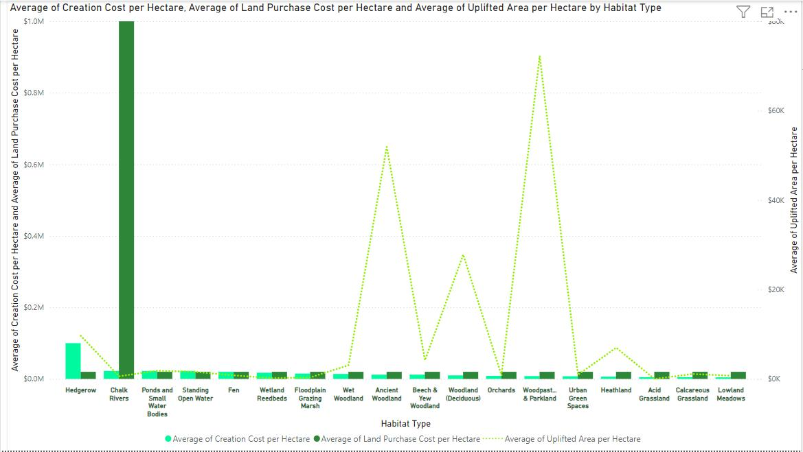

**Figure 26: Land and Uplifted Area Calculation**

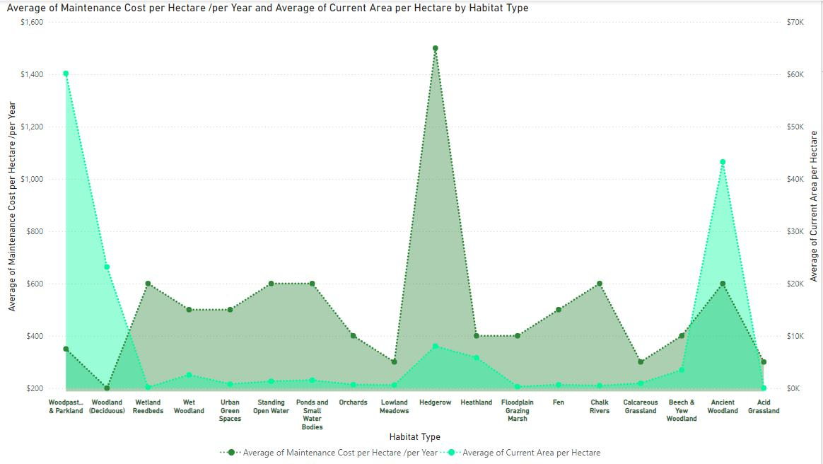

**Figure 27: Maintenance Projection**

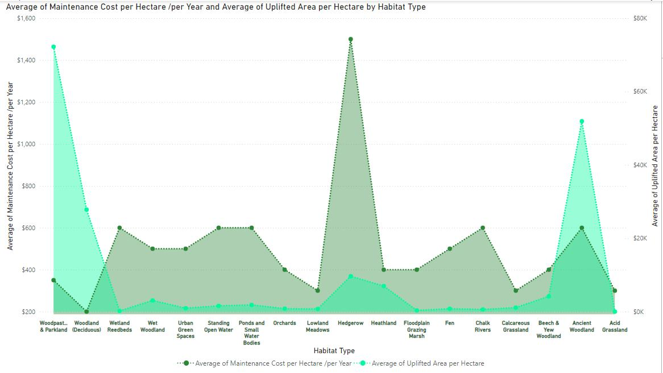

**Figure 28: Maintenance Uplifted Cost Projection**

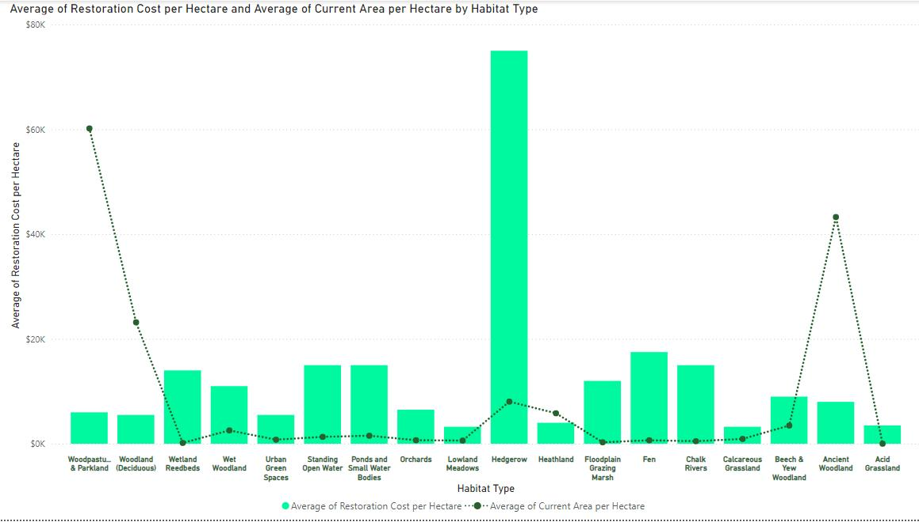

**Figure 29: Restoration Projection**

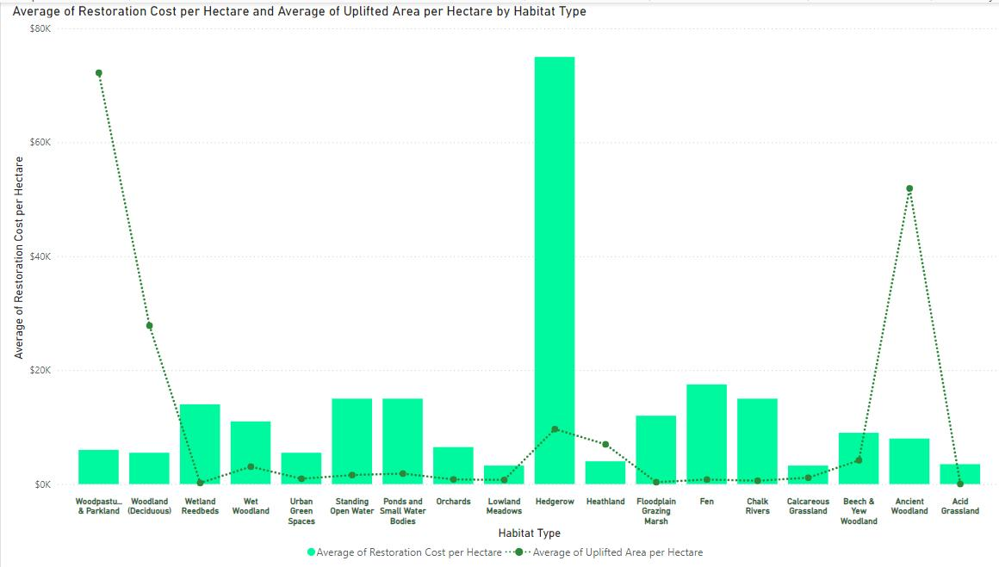

**Figure 30: Restoration Projection - Uplifted**

## Analytical Adjustments and Assumptions

The analytical approach was refined throughout the project to ensure that the findings were both accurate and aligned with Surrey's biodiversity and financial objectives. These refinements were informed by data visualizations and the overall analysis, which revealed key insights that necessitated adjustments in the project's methodology.

One major adjustment involved modifying the uplift targets for specific habitats. Initial plans to uniformly apply a 20% Biodiversity Net Gain (BNG) target across all habitats were reconsidered after visualizations highlighted the unique challenges faced by fragmented habitats like Wet Woodland and Hedgerows. The analysis showed that a uniform target could lead to unrealistic expectations for these habitats. Therefore, more tailored uplift targets were adopted, better reflecting the ecological conditions and potential of each habitat.

Financial projections also required careful adjustment. The assumption of a 2.2% annual inflation rate was integral to the cost models, influencing the projected expenses for land acquisition, habitat creation, and long-term maintenance. This assumption was based on historical trends and was visually supported by cost projections over time, emphasizing the need for inflation consideration in long-term financial planning. The assumption of linear growth in land values, derived from observed data trends, further ensured that financial models were grounded in market realities.

Another key assumption was that species response to habitat restoration would be positive, with larger, more connected habitats supporting higher biodiversity levels. This assumption, supported by diagnostic analysis and visualizations, linked habitat size to species survival rates. However, this assumption also introduced some uncertainty, as species responses can be unpredictable due to factors not fully captured in the analysis, such as specific ecological interactions or unforeseen environmental changes.

These adjustments and assumptions were essential for ensuring the project’s success, though they also highlighted the importance of continuous monitoring and adaptability. By grounding these decisions in data-driven insights, the project remains responsive to new information, allowing for adjustments as the project progresses.

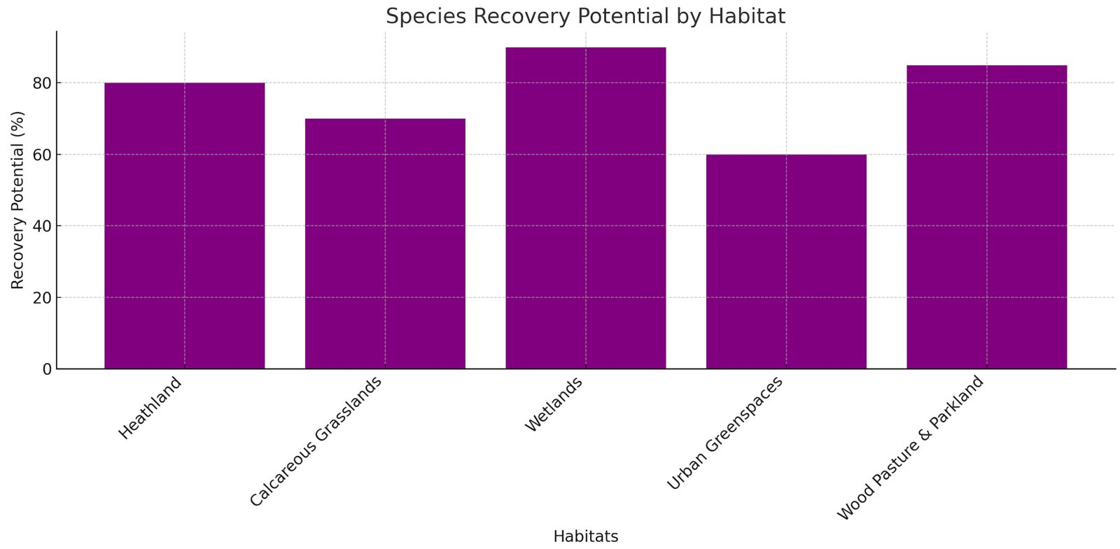

**Figure 31: Species Recovery Potential**

# Findings and Recommendations

In the pursuit of Surrey's 20% Biodiversity Net Gain (BNG) by 2030, the analysis has identified critical insights that shape the path forward. The focus on habitats such as Heathland, Calcareous Grasslands, Reedbeds, and Urban Green Spaces emerged as pivotal due to their balance of high ecological value and relatively manageable restoration costs. These findings underline the strategic importance of targeting cost-effective habitats, which can deliver significant biodiversity gains while staying within financial constraints.

This section will explore the implications of these findings in relation to established conservation theories, address any unexpected outcomes, and provide actionable recommendations tailored to Surrey's unique ecological landscape. These recommendations are designed to ensure that the BNG targets are met in a way that is both ecologically and financially sustainable.

## Project Contribution

The integration of financial modelling, ecological assessment, and spatial analysis has led to significant advancements in understanding how these tools can be effectively used to guide biodiversity conservation efforts. The methodology applied here successfully identified key habitats, such as Heathland, Calcareous Grasslands, Reedbeds, and Urban Green Spaces, as the most strategic areas for restoration, based on their potential for significant biodiversity gains and cost-effectiveness.

One of the pivotal contributions of this project lies in challenging the conventional focus on more expensive habitats like Rivers and Floodplain Grazing Marshlands. The findings revealed that equally impactful biodiversity improvements could be achieved by investing in less costly but highly effective habitats. This insight suggests that conservation efforts should prioritize habitats that offer the highest ecological returns on investment, particularly in resource-limited scenarios.

The project’s integration of financial and ecological data into a cohesive strategy provides a practical framework for achieving biodiversity targets within financial constraints. This approach not only aligns with current best practices but also extends them by demonstrating that substantial biodiversity gains can be realized through targeted, cost-effective investments.

In the broader context of biodiversity conservation, this project underscores the importance of a data-driven approach that considers both ecological and economic factors. The methodologies and insights generated here offer a replicable model for other regions facing similar challenges, contributing to more sustainable and efficient conservation practices on a wider scale.

## Recommendations

To effectively achieve the 20% Biodiversity Net Gain (BNG) in Surrey by 2030, the following strategic recommendations have been developed based on the comprehensive analysis and findings of this project. These recommendations are designed to maximize ecological impact while considering financial constraints and practical feasibility.

Implementing a phased restoration approach is crucial. Restoration efforts should begin with the most degraded and fragmented habitats, such as Wet Woodland and Hedgerows. These areas offer the potential for immediate biodiversity benefits with targeted restoration actions. Prioritizing these habitats ensures that early conservation efforts have a substantial impact, with plans to expand to other important habitats like Heathland and Calcareous Grasslands as additional resources become available.

Establishing a comprehensive biodiversity monitoring system is essential. Developing a robust framework for monitoring biodiversity across Surrey over time will provide critical data for adaptive management strategies. Utilizing advanced GIS tools and remote sensing technology, this system will enable real-time tracking of biodiversity changes, ensuring that conservation actions remain effective and responsive to emerging challenges.

Implementing focused species recovery initiatives is necessary. Targeting at-risk species, particularly keystone or indicator species, is vital for maintaining ecosystem health. These recovery programs should encompass habitat-specific restoration efforts, captive breeding, and enhanced legal protections to secure the long-term survival of these species. Concentrating efforts on these critical species will help maintain the ecological integrity of Surrey’s ecosystems.

Enhancing habitat connectivity is a priority. Investing in projects that improve the links between fragmented habitats, especially those with high ecological value like Reedbeds and Urban Green Spaces, will facilitate species movement and genetic exchange. Creating corridors and buffer zones will counteract the effects of habitat fragmentation, ensuring the long-term viability of Surrey’s biodiversity.

Optimizing resource allocation by focusing on cost-effective habitats is essential for financial sustainability. Prioritizing the restoration and maintenance of habitats like Heathland and Urban Green Spaces, which offer high ecological returns on investment, will allow Surrey Wildlife Trust to achieve significant biodiversity gains while staying within budgetary constraints. This approach ensures that resources are directed where they will have the most impact.

## Project Limitations

While this project has contributed valuable insights into biodiversity conservation planning, several limitations emerged during the analysis. The availability and granularity of ecological data were significant challenges. Specifically, gaps in data related to certain species distributions and habitat conditions may have constrained the precision of the ecological assessments. These data limitations potentially introduced biases, particularly in identifying and prioritizing key habitats for restoration, which could have affected the accuracy of the recommendations.

Financial constraints also played a crucial role in shaping the project’s outcomes. Due to budgetary limitations, high-cost habitats like Rivers and Floodplain Grazing Marshlands were excluded from the restoration plan, despite their recognized ecological value. This exclusion underscores the difficult trade-offs that arise when financial resources are limited, potentially leading to a focus on more cost-effective, but not necessarily the most ecologically critical, habitats.

The analytical framework itself, while robust, faced constraints in modelling the full complexity of ecological interactions and long-term sustainability. For example, the assumptions made regarding habitat restoration costs and ecological uplift may have simplified the actual dynamics, particularly in habitats with complex interdependencies. These simplifications could result in underestimations of the true ecological and financial costs involved in achieving the 20% Biodiversity Net Gain (BNG) target.

Finally, the project’s reliance on existing datasets and models may limit the generalizability of the findings. While the methodologies used are applicable to Surrey, different regions with varying ecological and economic contexts might require tailored approaches. Future projects should consider integrating more localized data and exploring alternative modelling techniques to address these limitations and enhance the robustness of conservation planning.

## Future Opportunities for Research

The outcomes of this project suggest several avenues for future research, which could significantly enhance both the ecological and financial sustainability of biodiversity conservation efforts. A key area for further study is the long-term monitoring and evaluation of the ecological impacts of the recommended restoration strategies. While the project provides a framework for immediate biodiversity gains, understanding how these interventions perform over time is crucial. Longitudinal studies could assess habitat resilience, species recovery rates, and the overall stability of restored ecosystems, ensuring that the gains achieved are not only immediate but also sustainable in the long term.

Another promising direction is the exploration of more advanced predictive modelling techniques, such as machine learning and artificial intelligence. These tools could offer more refined cost projections and impact estimates by analysing complex datasets and identifying patterns that traditional models might overlook. For instance, machine learning algorithms could be employed to predict habitat responses to various restoration interventions under different environmental conditions, allowing for more adaptive and responsive conservation strategies.

Further research could also investigate the feasibility of integrating higher-cost habitats into the conservation plan. While this project prioritized cost-effective habitats due to financial constraints, future studies could explore scenarios where additional funding is secured. This could involve conducting detailed cost-benefit analyses of including habitats like Rivers and Floodplain Grazing Marshlands, assessing their potential to deliver long-term ecological benefits that could justify the higher initial investment. Such research would be valuable in building a more comprehensive case for securing external funding or reallocating existing resources.

Expanding the study to include different regions with varying ecological and economic contexts would also provide valuable insights. Comparative studies could help generalize the methodologies and findings of this project, refining them for broader application. This would not only test the robustness of the current approach but also identify region-specific adaptations that could enhance conservation outcomes in diverse settings.

Lastly, there is potential to explore the socio-economic dimensions of biodiversity conservation more deeply. Understanding how local communities, stakeholders, and policy frameworks interact with conservation efforts could lead to more socially inclusive and politically feasible strategies. Future research could examine the role of community engagement, economic incentives, and policy interventions in supporting long-term biodiversity gains, ensuring that conservation efforts are aligned with broader societal goals.

These research directions would not only build on the current project’s findings but also push the boundaries of what is achievable in biodiversity conservation, ultimately contributing to more effective and sustainable environmental management strategies.

# Conclusion

Achieving a 20% Biodiversity Net Gain (BNG) in Surrey by 2030, sets out to evaluate the feasibility and implications of this goal with a primary focus on species protection. The project aimed to develop a comprehensive framework that integrates financial, ecological, and spatial analyses to guide Surrey's conservation efforts effectively, ensuring that biodiversity gains are maximized within the constraints of available resources. This conclusion summarizes the key findings, reflects on the methodologies employed, and underscores the significance of this work in advancing biodiversity conservation practices.

The project's main findings underscore the importance of targeting cost-effective habitats that offer high ecological returns on investment. Habitats such as Heathland, Calcareous Grasslands, Reedbeds, and Urban Green Spaces emerged as strategic areas for restoration, balancing ecological value with manageable restoration costs. The analysis also challenged traditional conservation priorities by demonstrating that impactful biodiversity improvements can be achieved without necessarily focusing on the most expensive habitats. This insight is particularly valuable in resource-limited scenarios, where efficient resource allocation is crucial.

The methodologies employed in this project—financial modelling, ecological evaluation, and spatial analysis—proved to be effective in achieving the project’s objectives. The integration of these approaches allowed for a nuanced understanding of the trade-offs involved in conservation efforts, ensuring that financial investments are directed toward areas with the most significant ecological impact. Tools such as Geographic Information Systems (GIS) and predictive modelling techniques provided a robust framework for analysing habitat connectivity and species distribution, enhancing the project's overall effectiveness.

The analysis process itself was methodically structured to assess current biodiversity levels in Surrey, predict the financial requirements for achieving the BNG target, and prescribe optimal strategies for habitat restoration and maintenance. Descriptive analytics laid the foundation by establishing baseline conditions, while diagnostic analytics identified key factors driving observed trends. Predictive analytics offered forecasts of future habitat areas and financial needs, and prescriptive analytics provided actionable recommendations, ensuring that the project’s strategies were both data-driven and aligned with Surrey’s conservation goals.

One of the most significant insights from this project is the necessity of a data-driven approach that integrates both ecological and economic factors into biodiversity conservation strategies. The findings demonstrate the value of combining financial and ecological data into a cohesive strategy, offering a replicable model for other regions facing similar conservation challenges. The practical recommendations developed—such as phased restoration efforts, the establishment of a biodiversity monitoring framework, and targeted species recovery initiatives—provide actionable steps for Surrey Wildlife Trust and other stakeholders to achieve their conservation goals.

Reflecting on the analytical process, the success of the project was underpinned by the careful selection of methodologies and tools that aligned with the project’s objectives. The use of scenario analysis and advanced data visualization techniques, such as Power BI, allowed for a comprehensive exploration of potential outcomes under different conservation strategies. These methodologies not only enhanced the accuracy of the findings but also facilitated effective communication of the results to stakeholders, ensuring that the insights gained were both actionable and impactful.

This project contributes to the broader field of biodiversity conservation by offering a practical, data-driven framework that can be adapted to different regional contexts. The findings align with existing knowledge on the importance of habitat connectivity and the role of cost-effective conservation strategies but also challenge the conventional emphasis on more expensive habitats. This project reinforces the idea that significant biodiversity gains can be achieved through targeted, strategic investments, even in resource-constrained environments.

The practical implications of this work are significant. By providing a clear, actionable roadmap for achieving the 20% BNG target in Surrey, this project supports the region’s long-term conservation goals. The recommendations are not only relevant to Surrey but also offer valuable insights for other regions seeking to balance ecological and financial considerations in their conservation efforts.

While the project has laid a solid foundation for biodiversity conservation in Surrey, it also opens the door for future research. Long-term monitoring of the ecological impacts of the recommended strategies will be crucial to ensuring their sustainability. Additionally, exploring more advanced predictive modelling techniques could further refine cost projections and impact assessments, enhancing the adaptability and effectiveness of conservation planning.

In conclusion, this project has successfully met its objectives by developing a comprehensive framework that integrates financial, ecological, and spatial analyses to guide biodiversity conservation in Surrey. The findings and recommendations presented here not only contribute to the region’s conservation efforts but also offer a replicable model for other regions facing similar challenges. As the world grapples with the accelerating decline in biodiversity, projects like this underscore the importance of a strategic, data-driven approach to conservation that is both ecologically sound and economically viable.

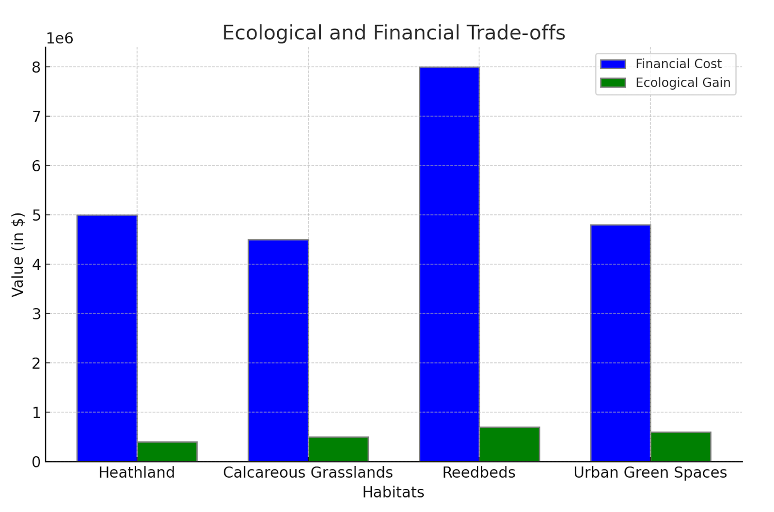

**Figure 32: Ecological Financial Trade-offs**

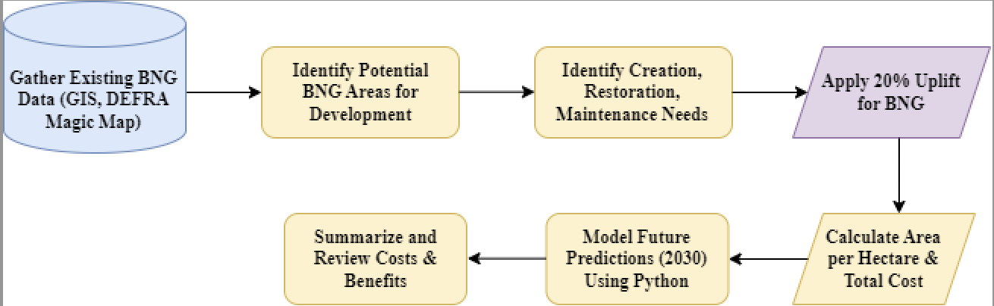

Figure 33: Workflow

Cost Calculation of Habitat Creation

This table shows estimated costs of creating, maintaining and restoring semi-natural habitats over 30 years. The values used to calculate the costs of Nature Recovery for this analysis are the mean value from the different estimates of the costs per ha of creating a new semi-natural habitat and maintaining this for30 years. Restoration costs, i.e. for enhancing the ecological condition of an existing semi-natural habitats, are included here for comparison, but were not used in estimating the cost of Nature Recovery. Broad habitat type is shown in column one, with the specific habitat cost estimates detailed under these.

|  |  |  |  |
| --- | --- | --- | --- |
| **Broad**  **Habitat Type** | **Creation costs** | **Restoration Costs** | **Maintenance costs** |
| Heathland | ‘**Heathland’**     Current Area = 5822.9 hectares   20% Uplift Area:   5,822.9 × 0.20 = 1,164.58 hectares   Total Area after Uplift: 6,987.48 hectares   Creation Costs per Hectare = £6,500   Land Purchase cost = £20,000    **Creation Costs:**  **Land Purchase:**  1,164.58 × £20,000 = £23,291,600  **Habitat Creation:**  1,164.58 × £10,000 = £11,645,800  **Total Creation Cost:**  £23,291,600 + £11,645,800 =**£34,937,400**   |  | | --- | |  | | ‘**Heathland’**    Restoration Costs per Hectare = £4,000      **Total Restoration Costs:**  6,987.48 × £4,000 = **£27,949,920** | ‘**Heathland’**    Maintenance Costs per Hectare per year = £400      **Total Maintenance Costs till 2030:**  6,987.48 × £400 × 6 × 2.2% = **£16,769,952** |
| Calcareous Grassland | ‘**Calcareous Grassland’**     Current Area = 924.4 hectares   20% Uplift Area: 184.88 hectares  Total Area after Uplift: 1,109.28 hectares   Creation Costs per Hectare = £5,000   Land Purchase cost = £20,000   |  | | --- | |  |   **Creation Costs:**  **Land Purchase:**  184.88 × £20,000 = £3,697,600**Habitat Creation:**  184.88 × £5,000 = £924,400  **Total Creation Cost:**  **£4,622,000** | ‘**Calcareous Grassland’**    Restoration Costs per Hectare = £3,250      **Total Restoration Costs:**  1,109.28 × £3,250 = £3,604,160 | ‘**Calcareous Grassland’**    Maintenance Costs per Hectare per year = £300      **Total Maintenance Costs for 6 years:**  1,109.28 × £300 × 6 × 2.2% =**£437715.648** |
| Lowland Meadows | **‘Lowland Meadows’**     Current Area = 611 hectares   20% Uplift Area = 122.2 hectares   Total Area after Uplift = 733.2 hectares   Creation Costs per Hectare = £4,500   Land Purchase cost = £20,000   |  | | --- | |  |   **Creation Costs:**  **Land Purchase:**  122.2 × £20,000 = £2,444,000  **Habitat Creation:**  122.2 × £4,500 = **£549,900**  **Total Creation Cost:**  **£2,993,900** | **‘Lowland Meadows’**    Restoration Costs per Hectare = £3,250      **Total Restoration Costs:**  733.2 × £3,250 =**£2,379,900** | **‘Lowland Meadows’**    Maintenance Costs per Hectare per year = £300      **Total Maintenance Costs for 6 years:**  733.2 × £300 × 6 × 2.2% **= £289349.76** |
| Ponds and  Small Water Bodies | ‘**Ponds and Small Water Bodies’**     Current Area = 1,532 hectares   20% Uplift Area = 306.4 hectares   Total Area after Uplift = 1,838.4 hectares   Creation Costs per Hectare = £10,000   Land Purchase cost = £20,000    **Creation Costs:**  **Land Purchase:**  306.4 × £20,000 = £6,128,000  **Habitat Creation:**  1,164.58 × £10,000 = £11,645,800  **Total Creation Cost:**  £23,291,600 + £11,645,800 =**£34,937,400**   |  | | --- | |  | | ‘**Ponds and Small Water Bodies’**    Restoration Costs per Hectare = £15,000      **Total Restoration Costs:**  1,838.4 × £15,000 = **£27,576,000** | ‘**Ponds and Small Water Bodies’**    Maintenance Costs per Hectare per year = £600      **Total Maintenance Costs for 6 years:**  1,838.4 × £600 × 6 × 2.2% = **£1,45,645.44** |
| Woodland (Deciduous) | **‘Woodland (Deciduous)’**     Current Area = 23,182 hectares   20% Uplift Area = 4,636.4 hectares     Total Area after Uplift = 27,818.4 hectares Creation Costs per Hectare = £10,000   Land Purchase cost = £20,000   |  | | --- | |  |   **Creation Costs:**  **Land Purchase:**  4,636.4 × £20,000 = **£92,728,000**  **Habitat Creation:**  4,636.4 × £10,000 = **£46,364,000**  **Total Creation Cost:**  **£139,092,000** | **‘Woodland (Deciduous)’**    Restoration Costs per Hectare = £5,500      **Total Restoration Costs:**  27,818.4 × £5,500 = **£152,001,200** | **‘Woodland (Deciduous)’**    Maintenance Costs per Hectare per year = £200      **Total Maintenance Costs for 6 years:**  27,818.4 × £200 × 6 × 2.2% = **£733619.68** |
| Urban Green Spaces | **‘Urban Green Spaces’**     Current Area = 777 hectares   20% Uplift Area = 155.4 hectares   Total Area after Uplift = 932.4 hectares   Creation Costs per Hectare = £7,500   Land Purchase cost = £20,000   |  | | --- | |  |   **Creation Costs:**  **Land Purchase:**  155.4 × £20,000 = £3,108,000  **Habitat Creation:**  155.4 × £7,500 = £1,165,500  **Total Creation Cost:**  **£4,273,500** | **‘Urban Green Spaces’**    Restoration Costs per Hectare = £5,500      **Total Restoration Costs:**  932.4 × £5500 = **£5,128,200** | **‘Urban Green Spaces’**    Maintenance Costs per Hectare per year = £500      **Total Maintenance Costs for 6 years:**   932.4 × £500 × 6 × 2.2% = **£616,362.88** |
| Wetland Reedbeds | **‘Wetland Reedbeds’**     Current Area = 159 hectares   20% Uplift Area = 31.8 hectares   Total Area after Uplift = 190.8 hectares   Creation Costs per Hectare = £17,500   Land Purchase cost = £20,000   |  | | --- | |  |   **Creation Costs:**  **Land Purchase:**  31.8 × £20,000 = £6,36,000  **Habitat Creation:**  31.8 × £17,500 = £5,56,500  **Total Creation Cost:**  **£1192500** | **‘Wetland Reedbeds’**    Restoration Costs per Hectare = £5,500      **Total Restoration Costs:**  190.8 × £14,000 = **£2,671,200** | **‘Wetland Reedbeds’**    Maintenance Costs per Hectare per year = £500      **Total Maintenance Costs for 6 years:**   190.8 × £600 ×6 × 2.2% = **£15,123.84** |
| Orchards | **‘Orchards’**     Current Area = 677 hectares   20% Uplift Area = 135.4 hectares   Total Area after Uplift = 812.4 hectares   Creation Costs per Hectare = £8,500   Land Purchase cost = £20,000   |  | | --- | |  |   **Creation Costs:**  **Land Purchase:**  135.4 × £20,000 = £2,708,000  **Habitat Creation:**  135.4 × £8,500 = £1,150,900  **Total Creation Cost:**  **£3,858,900** | **‘Orchards’**    Restoration Costs per Hectare = £6,500      **Total Restoration Costs:**  812.4 × £6,500 = **£5,280,600** | **‘Orchards’**    Maintenance Costs per Hectare per year = £500      **Total Maintenance Costs for 6 years:**   812.4 × £400 × 6 × 2.2% = **£42,921.12** |
| Chalk Rivers | **‘Chalk Rivers’**     Current Area = 490 hectares   20% Uplift Area = 98 hectares   Total Area after Uplift = 588 hectares   Creation Costs per Hectare = £22,500   Land Purchase cost = £1,000,000   |  | | --- | |  |   **Creation Costs:**  **Land Purchase:**  98 × £1,000,000 = £98,000,000  **Habitat Creation:**  98 × £22,500 = £2,205,000  **Total Creation Cost:**  **£100,205,000** | **‘Chalk Rivers’**    Restoration Costs per Hectare = £15,000      **Total Restoration Costs:**  588 × £15,000 = **£8,820,000** | **‘Chalk Rivers’**    Maintenance Costs per Hectare per year = £600      **Total Maintenance Costs for 6 years:**   588 × £600 × 6 × 2.2% = **£46,430.88** |

|  |  |  |  |  |
| --- | --- | --- | --- | --- |
| Floodplain Grazing Marsh | **‘Floodplain Grazing Marsh’**     Current Area = 281hectares   20% Uplift Area = 56.2 hectares   Total Area after Uplift = 337.2 hectares   Creation Costs per Hectare = £15,000   Land Purchase cost = £20,000   |  | | --- | |  |   **Creation Costs:**  **Land Purchase:**  56.2 × £20,000 = £1,124,000  **Habitat Creation:**  56.2 × £15,000 = £8,43,000  **Total Creation Cost:**  **£1,967,000** | **‘Floodplain Grazing Marsh’**    Restoration Costs per Hectare = £12,000      **Total Restoration Costs:**  337.2 × £12,000 = **£4,046,400** | **‘Floodplain Grazing Marsh’**    Maintenance Costs per Hectare per year = £400      **Total Maintenance Costs for 6 years:**   337.2 × £400 × 6 × 2.2% = **£17,814.24** |
| Fen | **‘Fen’**     Current Area = 662.8hectares   20% Uplift Area = 132.56 hectares   Total Area after Uplift = 795.36 hectares   Creation Costs per Hectare = £20,000   Land Purchase cost = £20,000   |  | | --- | |  |   **Creation Costs:**  **Land Purchase:**  132.56 × £20,000 = **£2,651,200**  **Habitat Creation:**  32.56 × £20,000 = **£2,651,200**  **Total Creation Cost:**  **£5,302,400** | **‘Fen’**    Restoration Costs per Hectare = £17,500      **Total Restoration Costs:**  795.36 × £17,500 = **£13,918,800** | **‘Fen’**    Maintenance Costs per Hectare per year = £500      **Total Maintenance Costs for 6 years:**   795.36 × £500 × 6 × 2.2% = **£52,593.36** |

|  |  |  |  |  |
| --- | --- | --- | --- | --- |
| Wood Pasture & Parkland | **‘Wood Pasture & Parkland’**     Current Area = 60,179hectares   20% Uplift Area = 12,035.8 hectares  Total Area after Uplift = 72,214.8 hectares   Creation Costs per Hectare = £8,000   Land Purchase cost = £20,000   |  | | --- | |  |   **Creation Costs:**  **Land Purchase:**  12,035.8 × £20,000 = £240,716,000  **Habitat Creation:**  12,035.8 × £8,000 = £96,286,400  **Total Creation Cost:**  **£337,002,400** | **‘Wood Pasture & Parkland’**    Restoration Costs per Hectare = £6,000      **Total Restoration Costs:**  72,214.8 × £6,000 = **£433,288,800** | **‘Wood Pasture & Parkland’**    Maintenance Costs per Hectare per year = £350      **Total Maintenance Costs for 6 years:**   72,214.8 × £350 × 6 × 2.2% = **£332,288.32** |
| Acid Grassland | **‘Acid Grassland’**     Current Area = 11hectares   20% Uplift Area = 2.2 hectares   Total Area after Uplift = 13.2 hectares   Creation Costs per Hectare = £5,000   Land Purchase cost = £20,000   |  | | --- | |  |   **Creation Costs:**  **Land Purchase:**  2.2 × £20,000 = £44,000  **Habitat Creation:**  2.2 × £5,000 = £11,000  **Total Creation Cost:**  **£55,000** | **‘Acid Grassland’**    Restoration Costs per Hectare = £3,500      **Total Restoration Costs:**  13.2 × £3,500 = £46,200 | **‘Acid Grassland’**    Maintenance Costs per Hectare per year = £300      **Total Maintenance Costs for 6 years:**   13.2 × £300 × 6 × 2.2% = £522.72 |

|  |  |  |  |  |
| --- | --- | --- | --- | --- |
| Wet Woodland | **‘Wet Woodland’**     Current Area = 2,549hectares   20% Uplift Area = 509.8 hectares  Total Area after Uplift = 3,058.8 hectares   Creation Costs per Hectare = £14,000   Land Purchase cost = £20,000   |  | | --- | |  |   **Creation Costs:**  **Land Purchase:**  509.8 × £20,000 = £10,196,000  **Habitat Creation:**  509.8 × £14,000 = £7,137,200  **Total Creation Cost:**  **£17,333,200** | **‘Wet Woodland’**    Restoration Costs per Hectare = £11,000      **Total Restoration Costs:**  3,058.8 × £11,000 = **£33,646,800** | **‘Wet Woodland’**    Maintenance Costs per Hectare per year = £500      **Total Maintenance Costs for 6 years:**   3058.8 × £500 × 6 ×2.2% = **£201,878.88** |
| Beech & Yew Woodland | **‘Beech & Yew Woodland’**     Current Area = 3,477hectares   20% Uplift Area = 2.2 hectares   Total Area after Uplift = 4,172.4 hectares   Creation Costs per Hectare = £12,000   Land Purchase cost = £20,000   |  | | --- | |  |   **Creation Costs:**  **Land Purchase:**  695.4 × £20,000 = £13,908,000  **Habitat Creation:**  695.4 × £12,000 = £8,344,800  **Total Creation Cost:**  **£22,252,800** | **‘Beech & Yew Woodland’**    Restoration Costs per Hectare = £9,000      **Total Restoration Costs:**  4,172.4 × £9,000 = **£37,551,600** | **‘Beech & Yew Woodland’**    Maintenance Costs per Hectare per year = £400      **Total Maintenance Costs for 6 years:**   4,172.4 × £400 × 6 × 2.2% = **£220,838.88** |

|  |  |  |  |  |
| --- | --- | --- | --- | --- |
| Standing Open Water | **‘Standing Open Water’**     Current Area = 1,319hectares   20% Uplift Area = 263.8 hectares  Total Area after Uplift = 1,582.8 hectares   Creation Costs per Hectare = £22,500   Land Purchase cost = £20,000   |  | | --- | |  |   **Creation Costs:**  **Land Purchase:**  263.8 × £20,000 = £5,276,000  **Habitat Creation:**  263.8 × £22,500 = £5,935,500  **Total Creation Cost:**  **£11,211,500** | **‘Standing Open Water’**    Restoration Costs per Hectare = £6,000      **Total Restoration Costs:**  1,582.8 × £6,000 = **£23,742,000** | **‘Standing Open Water’**    Maintenance Costs per Hectare per year = £600      **Total Maintenance Costs for 6 years:**   1,582.8 × £600 × 6 × 2.2% = **£125,370.24** |
| Hedgerow | **‘Hedgerow’**     Current Area = 8,044hectares   20% Uplift Area = 1.608.8 hectares   Total Area after Uplift = 9,652.8 hectares   Creation Costs per Hectare = £100,000   Land Purchase cost = £20,000   |  | | --- | |  |   **Creation Costs:**  **Land Purchase:**  1,608.8 × £20,000 = £32,176,000  **Habitat Creation:**  1,608.8 × £100,000 = £160,880,000  **Total Creation Cost:**  **£193,056,000** | **‘Hedgerow’**    Restoration Costs per Hectare = £75,000      **Total Restoration Costs:**   9,652.8 × £75,000 = **£723,960,000** | **‘Hedgerow’**    Maintenance Costs per Hectare per year = £1,500      **Total Maintenance Costs for 6 years:**   9,652.8 × £1,500 × 6 × 2.2% = **£1,912,972.64** |

|  |  |  |  |  |
| --- | --- | --- | --- | --- |
| Rivers (Including River Restoration) | **‘Rivers’**     Current Area = 490hectares   20% Uplift Area = 98 hectares   Total Area after Uplift = 588 hectares   Creation Costs per Hectare = £2,000,000   Land Purchase cost = £1,000,000   |  | | --- | |  |   **Creation Costs:**  **Land Purchase:**  98 × £1,000,000 = £98,000,000  **Habitat Creation:**  98 × £2,000,000 = £196,000,000  **Total Creation Cost:**  **£294,000,000** | **‘Rivers’**    Restoration Costs per Hectare = £1,500,000      **Total Restoration Costs:**   588 × £1,500,000 = **£882,000,000** | **‘Rivers’**    Maintenance Costs per Hectare per year = £150,000    **Total Maintenance Costs for 6 years:**   588 × £150,000 × 6 × 2.2% = **£11,612,160** |